UPtime

Solution Guide

V2.0

* Table of Contents

1 Headlines, Contacts & Training 4

Contacts: 4

How to read this guide 4

Prerequisites 4

Training: 5

2 Uptime Overview 6

UPtime Engagement Platform 7

The Modern Workplace Solution Framework 8

2.1 Systems of Engagement Layer: 9

2.2 Orchestration Layer: 10

2.3 Systems of Record Layer: 10

2.4 3rd Party Integrations Layer: 12

2.5 Integration and Workflow (all UPtime): 12

2.6 Analytics and Automation (all UPtime): 13

DXCi Integration & Workflow Design 13

UPtime Engagement Portal 14

UPtime Deployment Patterns 15

Platform X & ServiceNow Considerations 15

2.7 No Platform X 16

2.8 Partial Platform X 16

2.9 Full Platform X 17

Releases and Roadmap 17

3 Capability Mapping Checklist 20

Generic Areas 20

Device Management 21

Support 22

4 UPtime Services-Initial Release/R2 - WIP 23

4.1 General Services 25

4.2 Portal Services 27

4.3 Support Services 28

4.4 Knowledge Services 31

4.5 PC Lifecycle Services 33

4.6 Reportig and Analytics 35

**5****Technical architecture diagrams** 36

Uptime Development Environment 37

UPtime High Level Architecture 37

5.1 Integration Patterns 38

5.2 Front End / Back End split 38

UPtime Azure Architecture 39

UPtime Data Analytics Architecture 41

UPtime Notification Design 42

UPtime Microservices Architecture Overview 43

6 UPtime Bill of Materials (BOM) & Procurement 44

Bill of Materials (BOM) 44

Procurement process 45

**7****Process maps of non-technical services** 47

PC Device Lifecycle 48

Knowledge - Entitlement based Knowledge search using UPtime and ServiceNow 52

Agent Chat – Service Desk agent chat, with Sentiment Capture 53

Software Request 53

8 Develop Solution Strategy – Initial Release (R2) 55

Deal Qualification: 55

UPtime Integrations 56

Cloud Placement 57

Questionnaire 57

User experience examples 58

9 Management services 60

9.1 Delivery Location 60

9.2 Operational Model 60

9.3 Escalation matrix 61

9.4 Delivery SPOCs 61

10 Service Level Objectives(SLO’s) 63

UPtime Service Availability 64

Exceptions to Service Levels: 65

Server Availability Alerts 65

Change Management 65

Hours of Operation 66

Reporting 66

11 Develop Solution Cost 67

Costing Solution 67

Costing Tools 67

Not Included / Custom Costing 68

12 Security & Privacy 69

13 Transformation Solution - WIP 70

Discovery Workshop 70

Transformation Approach 71

14 Partner Strategy 73

15 Develop Pricing 74

16 Reference Information 75

17 Document Control 76

Amendment History 76

Solution Guide Reviewers & Approvers 76

18 Appendix 77

Acronyms 77



# Headlines, Contacts & Training

* Contacts:

|  |  |
| --- | --- |
| Role | Contact Details |
| Offering Manager | Henk Hoevelaken |
| Offering Lead | Michael Dempsey |
| Offering Architect | Harry Busby |
| Solution Architect | Bala Subramanyam / Emil Justin Samuel |
| Offering Engineer | Nguyen, Bang Cong |
| Product Owner | Colin Wright |
| Project Manager | Mahelia Ebenezer |
| Program Manager | Linda Becker |

* How to read this guide

The **structure** of this solution guide allows you to read and use it like:

* A **“book-style”, end-to-end story** that logically and sequentially goes through all the offering components and topics, with each section building on top of the previous:
* **Overview**: what is UPtime, what services UPtime can offer, UPtime offering evolution
* **UPtime Offering Components:** what are the different features and functionalities of UPtime offering and how we support them during the RUN phase, guidelines on the solution approach, technical details, etc.
* **Transition and Transformation (Build)**: how/who build the UPtime solution, out of the box setup of the base solution, integration with dependent service offerings, etc.
* **Delivery Model**: how DXC delivers the services, delivery locations, SPOCs
* **Costing & Pricing**: how to properly cost your design, cost components, layers (Per Client/Feature/User/Device/etc.) recommended CUs/PUs and commercials
* **Reference Information**: FAQ, Trainings, Key contacts, and further information

Each section is as self-sufficient as possible to provide all the needed information for the respective service or component. In addition, each section provide links to:

* Other sections of the Solution Guide to enable quick access
* External content such as training, vendor articles that provide additional, in-depth details on the specific subject / topic
* Prerequisites

The guide is designed to help you understand the UPtime Service offering and build a solution even if you have limited or no experience with UPtime. However, to make most out of this guide it is recommended to cover at minimum the following prerequisites:

* Have a general knowledge of UPtime – what it is, what are the different features and services, etc.
* Have a fair understanding of the Modern Workplace offering & sub-offerings
* Have a general knowledge of the features and functionalities of the UPtime Services – User Portal, Password Reset, Order/View PC Refresh, etc.
* Have completed the DXC UPtime Services **Tier 1- 4 trainings**. Details and links to the trainings are available in <reference to the Training link>
* Understand (or at least read the contents of) the capability guides containing the detailed technical information located here <reference to the Produce guide link>
* Training:
* Recordings of UPtime Training materials can be found https://dxcportal.sharepoint.com/:f:/r/sites/MWOfferingCollaterals/Shared%20Documents/1_Digital%20Support%20Services/1_Digital%20Support_GSD/UpTime/UPtime%20Video%20Recordings?csf=1&web=1&e=1kYNfi
* Other training materials are available for the topics:

1. Sales Enablement

2. Solution

3. Costing (check with Steve Solomon for the estimator recording)

4. Delivery (onboarding/T&T) (put the link for doc Mark/Tom has created)

1. Delivery (run and maintain) (put the link for doc Carlo has created)

# Uptime Overview

Digital Natives enter Workplace of the Future with today’s high levels of expectation for intuitive, interactive online self-service options. It is no wonder that employees expect consumer-level IT self-service at their workplace. The way that corporate IT organizations meet employee IT needs has changed. How IT people and technology need to be better married together – to work “smarter” in delivering better services and support.

Rebooting the enterprise user experience:

* Greater focus on the end user experience
* Provide the modern self-service and self-help users expect
* Secure, anytime, anywhere access
* Adoptions of ITIL’s continual service improvement practices

UPtime is DXC’s approach to providing fully integrated and automated Modern Workplace services to customers and to increase the overall value of Modern Workplace services by combining Automation, Analytics, and Intelligence.

* At its core is the functionality to allow employees to request new technology, manage their existing technology, and get support that enables them to be more productive. The ease of access to, and communication with IT, the quality of the offered self-service and self-help capabilities considering their consumer-world equivalents.
* The experience-led transformation framework ensures convergence of human-centred design and embeds the design into DXC’s UPtime solution that provides a set of interactive technologies and operating model to manage and consistently improve the user experience.

The picture below illustrates on a high level the components of the UPtime offering.

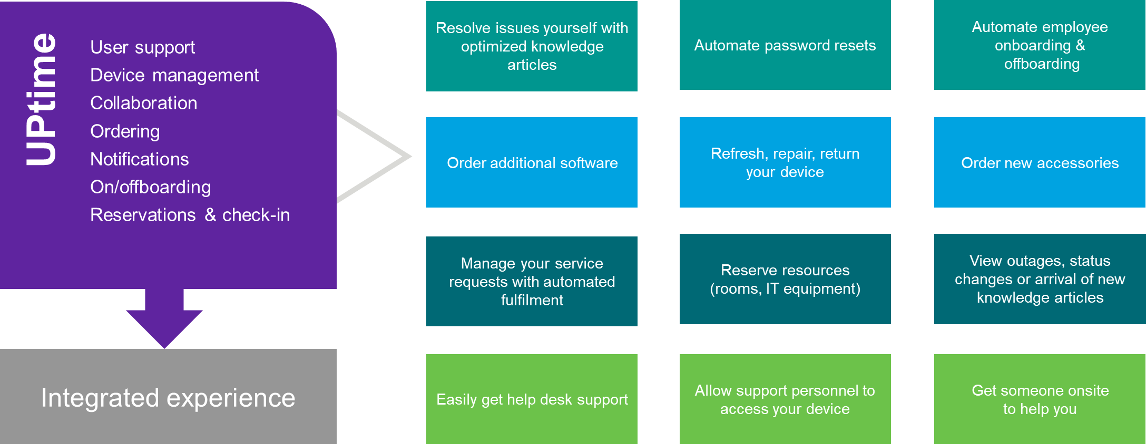

The main elements comprising UPtime are:

* A browser-based client application (Engagement portal) with which end users interact. As users navigate the portal or client application the available products and functionality are personalized to them based on user and asset criteria.
* A suite of integrated analytics, workflows, and automations. These orchestrate the end user journeys from across the UPtime ecosystem and automatically fulfils those requests. The workflows and integrations join the Modern Workplace technology stack together from across the portfolio. The Analytics brings together Operational and Experience data to form user Journey’s measured by XLA’s (Experience Level Agreements).

The core capabilities of the platform include:

* **Device intelligence** – to monitor device performance and user experience, enable investigation, and remediation of employee experience issues in real-time and at scale
* **Omni-channels** – our AI-based virtual support agent, incorporates natural language processing and conversational artificial intelligence to automate the resolution of questions, issues, and requests
* **Integration gateway** – to connect systems faster with pre-built templates and integration patterns to automate workflows
* **Sentiment management** – capture and analysis to pinpoints priority areas for improving technology experiences; this enables Experience Level Agreement (XLA) to drive services
* **Data Analytics** - combining operational data and experience data to provide significantly deeper customer insights

The UPtime solution is underpinned by a data-driven feedback loop and a continuous improvement team that analyses and detects problems, drives actions to integrate and automate to consistently improve customer experience.

* UPtime Digital Experience

**Portal**: A highly responsive, personalized, customer branded portal whether on browser or mobile provide access to Modern Workplace services like Service Desk, Support ticket interaction, Support Device Life Cycle, Access to Notifications, Knowledge for self-help. Track Asset information (HW/SW/services).

**Automation** to automatically fulfils service requests, provide low-touch resolution with the aim to quick return to productivity. We will have automation scripts for top-10 issues and Service request fulfilment.

**UPtime** **integrations**

* UPtime will integrate with (ITSM) IT Service Management solutions for System of record to provide – Incidents, Requests, Catalogue Knowledge, etc. whether it’s client owned ServiceNOW instance or DXC’s Platform X or a combination of both.
* Integration with existing authentication and authorization solution to provide Single Sign-On such as (Okta). Other authentication mechanisms will be added in the future.
* Integration with Service Desk to initiate the Chat (Amazon Connect Chat or MS Teams) as the primary means of interaction with IT Service Desk solution.
* AWS Connect integration with Teams for Chat services within Service Desk.
* Integration with OEM vendors for direct Device-ordering, and with DXC Gear for ordering PC accessories.
* Integration with remote takeover tools like LogMeIn (LMI)
* We can integrate with customer HR systems for deeper personalization

**Workflows** with the **Ability to consistently deliver a seamless user experience**

* This includes On/Off-boarding Users, Auto approvals and direct equipment ordering, part of Device life-cycle automations like - Device refresh, - Device return, - Device break/fix, etc.
* Flexible enterprise workflows configurable to BUs

**Notifications** includes User and group notifications, with the choice to define User notification preferences, Multichannel notifications as well as Password reset notification.

**Analytics** to Continuous monitoring and improvements of user experience by leverage automated O-data and X-data reporting and analytics to derive insights and to make automated (where appropriate) data-driven decisions.

* Ingest, analyse, and act on experience and operational and Telemetry data helps predict and prevent issues from happening

For completeness, the diagram above also includes services outside the UPtime offering. They are not part of the UPtime solution and need to be solutioned and costed separately as part of the overall Modern Workplace offering. Where appropriate, this solution guide includes references to the UPtime services.

* The Modern Workplace Solution Framework

UPtime lives within and is a key contributor to the Modern Workplace solution framework. The solution framework includes components from across the Modern Workplace portfolio and customer systems. It is broken into 6 key elements, described below are the UPtime portions of the framework.

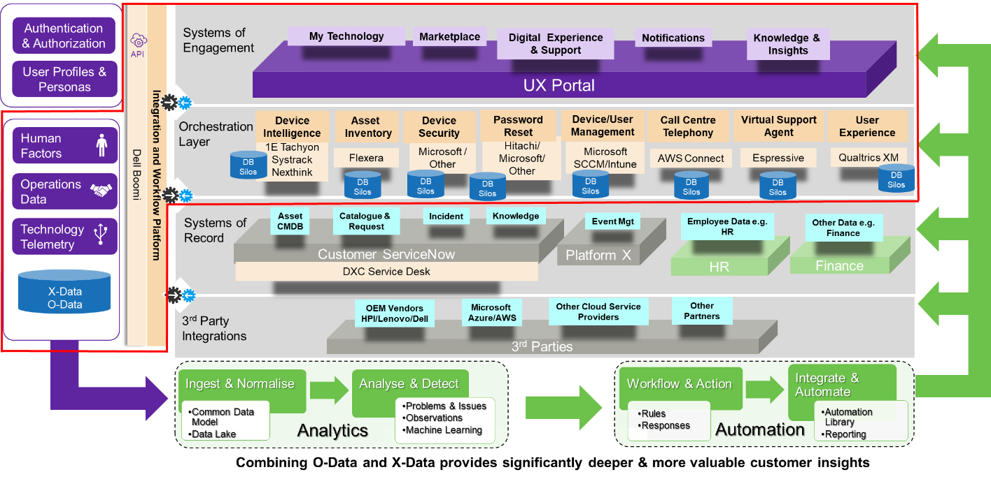

### Systems of Engagement Layer:

**These are the systems we present to end users to interact with, such as the UPtime Portal or Microsoft Teams. UPtime manages all service interactions through these systems.**

* **The UPtime portal**, an intuitive one-stop shop where end users can find what they are looking for, exactly when they need it. The portal is designed with end user experience at the forefront. Users can access the UPtime engagement platform through their device browser.
* It is incorporated with **marketplace** to facilitate the choice of hardware, software, and services.

Through UPtime, users can perform various activities including:

* **Digital Experience & Support through Omni-channels** – UPtime portal has option for users to start a chat with service desk as it will be integrated with Voice and Chat channels. We can integrate virtual agent, with advanced natural language processing to automate resolution of employee questions, issues, and requests with personalized responses.
* **Search for knowledge articles that will enable users for self-help:** To enable Knowledge Base Content search, UPtime will be integrated with Customer ServiceNow or Platform X ServiceNow or the forthcoming DXC conversational AI capability.
* Voice and Text based chat
  + Ability to consume outage messages when you begin (before user enters the queue)
  + Ability to send outage message whilst user is waiting in a queue
  + Ability for the user to register they are impacted by an Outage whilst waiting in the queue
  + Customised welcome message when a user begins
* **View notifications:** Users will be presented with Outage notifications in the “What’s New” section at the top of the Portal. Users will be presented with Outage notifications in the “What’s New” section at the top of the Portal that we just saw. It can be customized and target notifications to individuals, groups, or entire organizations.
* **Access chat or voice support:** UPtime portal will have option for users to start a chat with service desk as UPtime will be integrated with DXC Agile Service Desk Voice and chat channels. We can integrate UPtime with Microsoft 365 workloads like Teams for Chat, Receive Email notifications as well SMS/Text messages.

Refer**UPtime Engagement Portal**section for more details

### Orchestration Layer:

**This layer includes the services and tooling Modern Workplace uses to control, configure, and manage the Modern Workplace. UPtime brings Device Intelligence and Experience measures whilst the other components such as Device Management are provided by the rest of the offering portfolio.**

* **Device intelligence** – using third party toolsets like 1E Tachyon, Lakeside Systrack or Nexthink to monitor device performance and user experience, enable investigation, and remediation of employee issues in real time and at scale.

DXC’s UPtime Action Engine provides the mechanism to take telemetry feeds from end user devices, monitor for known events and trigger a corresponding workflow to drive automatic resolution. The data feeds can be from native tooling such as Microsoft Intune / Log Analytics or from third-party tools.

* UPtime will interact with **Asset** Inventory/**CMDB** to maintain the device record which enables management of the device from request to provisioning to ongoing maintenance and retirement. We can enhance **software asset** inventory to provide better control, visibility, and compliance of customer’s asset environments using Flexera as it is our preferred **Software Asset Management** solution and UPtime integrates with it.
* **AWS Connect** integration with Teams for Chat services within Service Desk solution.
* Using **Qualtrics as Experience management** (XM) solution to capture and analysis to identify priority areas for improving everyday technology experiences and employee productivity and job enablement, this enables Experience Level Agreement (XLA) to drive services. Provides a **feedback** option for end users to document their experience and their experience can be addressed and updated as the solution adapts over time
* **DXC adopts Continual** development to address the key issues faced by users based on analysis of operational and experience data. This enables auto-fix, low touch resolution to ensure quick return to productivity.

### Systems of Record Layer:

**These systems contain the records and data used throughout the Modern Workplace. The content can range from user CMDB through to Knowledge Articles. Some systems are customer owned and others are provided by DXC.**

* UPtime will interact with **Asset** Inventory/**CMDB** to maintain the device record which enables management of the device from request to provisioning to ongoing maintenance and retirement.
* **UPtime provides intelligent workflows** that are orchestrated with existing systems of record, the IT service management systems and the integrated portal designed with end user experience at the forefront. These workflows minimize unnecessary distractions whilst maximizing the impact of any information or action that a user must or may wish to take.
* Integrations with existing **IT Service management** mechanisms and using client authentication and authorisation channels, and collaboration channels. ITSM services are either provided in client owned ITSM System (Catalogue, Knowledge, Asset, and Incident) or DXC's Platform X service or any other third party ITSM toolsets like Service Manager, S-MAX, etc. DXC uses Application Programming Interface (API) technology to integrate knowledge management capabilities between customer ITSM platforms and DXC’s UPtime. DXC uses Microservice technology to integrate as a standard approach to connect with the various tables in the ITSM environment.
* The main integration functions are:
  + Search for knowledge using the end point ITSM search capability under the context of the user performing the search
  + Return knowledge articles and their content, including attachments
  + Provide knowledge article feedback; if an article is useful, rating and comments
  + Update knowledge article view counts
* UPtime will interact with **Asset** Inventory/**CMDB** to maintain the device record which enables management of the device from request to provisioning to ongoing maintenance and retirement
* **Catalogue & Request:** The UPtime solution will host a catalogue containing devices and software. The various catalogue entries can be curated into bundles which are made available based on personas. User can track the request status through the UPtime portal. During this process the UPtime will interact with DXC Asset Management capability to maintain the record be it Asset CMDB or Flexera and SCCM/Intune for Application Catalogue. It can be automated to to get an approval through Workflow and install an application automatically onto the device without end user intervention.
* With the "**UPtime**" self-service engagement platform, end users request services through the service catalog, and browse knowledge articles to solve their own issues—without getting a technician involved.
* DXC UPtime solution is integrated with our **Digital support** services, providing the user with a unified view of their devices, service requests, knowledge articles, open incidents etc.
* UPtime would be integrated with ServiceNow and Intune to provide a single point of access to all Workplace services provided to employees by DXC.
* **Search for knowledge articles that will enable users for self-help:** To enable Knowledge Base Content search, UPtime will be integrated with Customer ServiceNow or Platform X or Espressive Barista
* The self-service engagement platform can be configured to match your organization’s **brand** to provide an interface that looks and feels familiar—a key factor influencing self-service adoption.
* **UPtime** is flexible enough to integrate with HR database like HRMS, Workday and other finance/payroll systems based on the unique requirements for the client.

### 3rd Party Integrations Layer:

* These integrations join services from our partners into our managed service wrapper providing increased optimization and automation. UPtime provides integrations into our prime OEM’s such as Dell, Microsoft, Lenovo etc.
* UPtime solution uses a 3rd party workflow platform with robust procedures to update APIs. Some APIs they will provide the updates for (the ones they provide as Out of the Box (OOTB) connectors) others DXC will maintain and deploy. They are all performed using an API integration gateway.
* OEM Vendors: DXC UPtime will be used to co-ordinate and orchestrate the device lifecycle logistics. DXC will manage logistics in conjunction with the OEM. DXC will generate requests to the OEM for fulfilment and shipping directly to the user, subject the appropriate approvals.
* From the end user perspective, while submitting an order for PC refresh or replacement through UPtime, users will be presented with appropriate shipping options and confirm their delivery address with the ability to update their shipping address prior to the order being submitted. This is very useful especially during the pandemic and in the hybrid workplace.
* UPtime will keep the user informed with device shipment tracking details and relevant notifications. Once the new device has been delivered, DXC will also manage the process for returning the old device, this is enabled by proving the user with shipping instructions. Processes are available for escalating and reporting on device return metrics and driving compliance where necessary.
* UPtime will consume cloud service providers like Azure to host this portal services in the cloud as well other partners supporting the client.

### Integration and Workflow (all UPtime):

* This element joins the 4 layers together with a robust API ecosystem and pre-packaged workflows that form the user journeys.
* UPtime acts as Integration gateway to connect systems with pre-built templates and integration patterns to automate workflows.
* DXC uses a 3rd party workflow platform, **Boomi** with robust procedures to update API's. Some APIs’ they will provide the updates for the ones they provide as Out of the Box (OOTB) connectors. For others, DXC will maintain and deploy. They are all performed using an API integration gateway.
* **Automated workflows** pre-configured for regular activities. These include on boarding /off boarding, common support actions, equipment ordering with automated approvals. The UPtime Action Engine predicts and prevents issues from occurring, automating, and orchestrating many common processes and remediations, in many cases removing the need for user-initiated action.
* In each stage, Boomi workflows (UPtime Action Engine) updates workflows and will examine status. Boomi hosts templated & configurable workflows and connects to ITSM/ServiceNow and with ASD & Microsoft 365 for Notifications.
* The UPtime Action Engine can look for and help in many scenarios even if the resulting workflow is a notification to the end user to reboot their pc. We create a library of events to watch, workflows and automations. The library is created using both a central and distributed approach. Centrally we analyze data from many customers to determine events to monitor, workflow and automate. Our distributed approach harvests automations from customers with this solution and packages them up for re-use globally.
* Email Channel - UPtime provides email-to-ticket automation using Machine Learning to classify each email and a subsequent integration workflow to log the tickets within the ITSM platform. These inquiries are then matched against an approved automation script library or otherwise assigned to the appropriate ITSM resolver group where required.

### Analytics and Automation (all UPtime):

* This element is split into two, the 1st brings together the Operational data from each component deployed and combines it with the Experience data. This allows us to transform the data into user journey’s which can be reported on and visualized. The 2nd part uses the data to drive pro-active automation targeting increases in user productivity.
* **Employee Experience** – DXC will Utilise qualitative (user research and insights) and the quantitative (change impact assessment) data points to bring your people along on the journey and embedding the new ways of working, this an iterative process that support the deployment.
* **Data Analytics** - combining operational data and experience data to provide significantly deeper customer insights. **UPtime Embedded** **analytics** services incorporate operational data (tooling, ticket, and telemetry) with experience data (issues, performance, sentiment) to engage users, target notifications or predict and prevent issues. Analytics is performed on the combined data in DXCs data lake. UPtime combines operational data from devices, tickets, and telemetry with experience data from surveys and to provide better decision-making capabilities for by the users and IT admins.
* [DXCi Integration & Workflow Design](https://confluence.dxc.com/pages/viewpage.action?pageId=240310012)
* Diagram
* 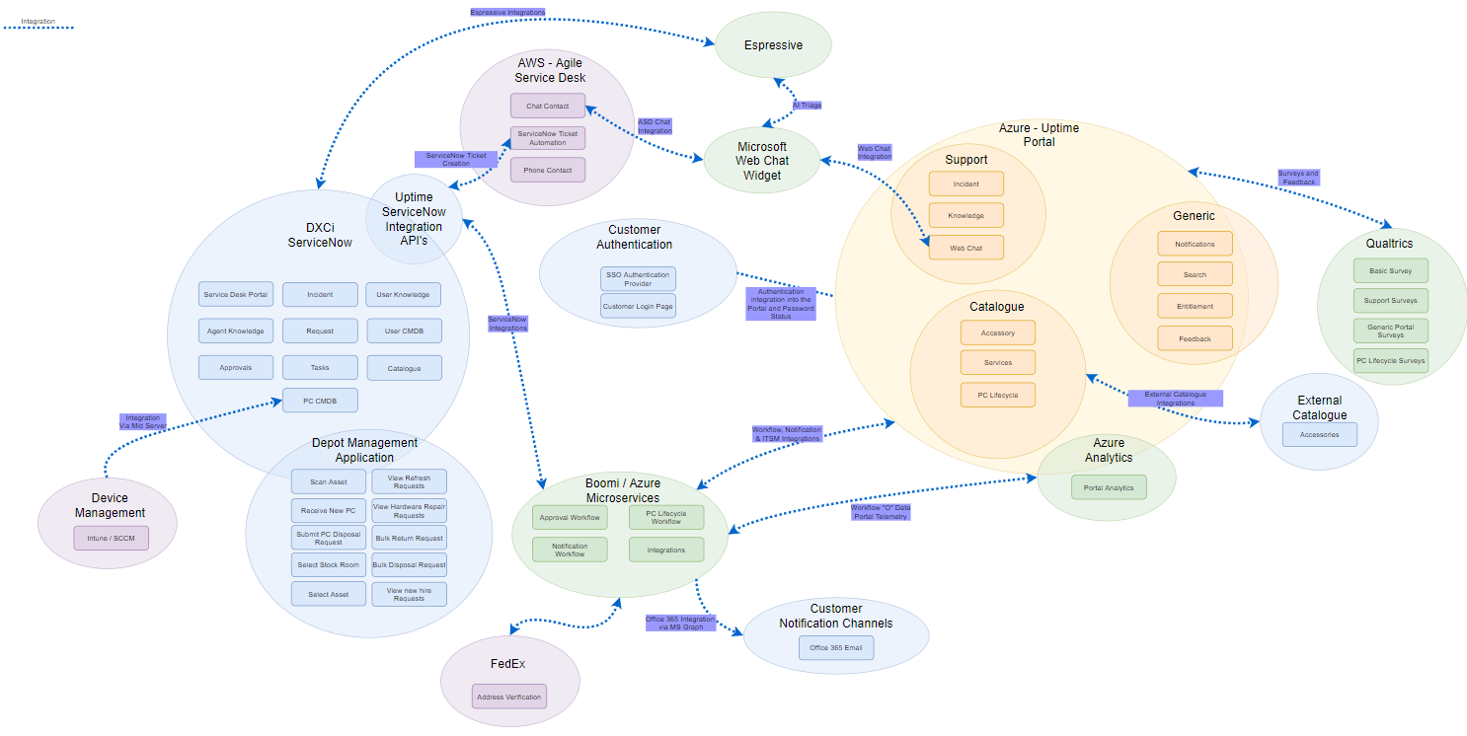
* UPtime Engagement Portal

The UPtime Engagement portal provides a single point of access to all Workplace services provided to employees by DXC. End Users can also personalise the interactions by selecting preferences for things such as notifications: type, channels, and frequency and access the UPtime portal from mobile, tablet or PC as the UPtime engagement platform is optimised for mobile and desktop.

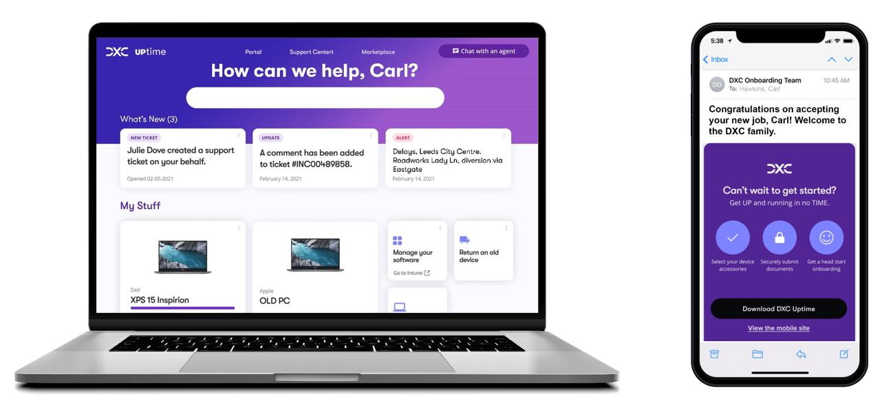

Through the UPtime portal, users can perform various activities including: -

* Search for knowledge articles that will enable users for self-help
* Access support through their medium of choice: voice, chat (via Microsoft Teams), web, or email.
* Perform device functions (report stolen, order new PC, etc.)
* Receive directed and personalized notifications relevant to their specific role (outages, status changes, new knowledge content)
* Review ticket content and status
* Users can access the Portal from mobile, tablet or PC as the UPtime engagement platform is optimised for mobile and desktop
* Users can also personalise the interactions by selecting preferences for things such as notifications: type, channels, and frequency

Please refer to the attached “[**Draft-UPtime_User_Guide_V1**](https://dxcportal.sharepoint.com/sites/MWAutomation/Shared%20Documents/General/Working%20Folder/Run%20and%20Maintain%20Documents/Draft-Uptime_User_Guide_V1.docx)**”** for more information about UPtime portal and features.



**Note:** The UPtime engagement portal look, and feel is being re-designed for Release-2.0 and some features are being added/removed/refined for now. This guide will be updated with latest features and functionalities of UPtime portal as soon as the Test/Dev portal is released for access (Before Nov,2021)

* UPtime Deployment Patterns
* UPtime is delivered as a cloud-based Software as a Service (SaaS) model for all deployment patterns and inherits the partner clouds SaaS availability. UPtime will consume cloud service providers like Azure to host the portal services in the cloud as well other partners supporting the client.
* UPtime connections use secure HTTPS Rest APIs for Web interface to client browser. Data is not copied or replicated in UPtime as we connect to it using APIs. It is hosted within primary region per customer and is not replicated across multiple regions within the base service.
* DXC providing the **Digital Support Services** and **Modern Device Management Services** is mandatory for all UPtime releases due to the nature of the portal and its focus. Other Modern workplace offerings like **Workplace Asset Management** and **Intelligent Collaboration** can be integrated with UPtime to make the most out of UPtime offering.
* **Note to SLA’s:** Evaluate during the qualification stage whether the client is eligible for UPtime solution based on the mantotory services, pre-requisites, and dependencies for your opportunity.
* UPtime integrates with the API solution at the end point, regardless of the ITSM platform it communicates to. DXC uses synchronous REST API’s that are real time. HTTPS protocol is used for integration using TLS encryption. DXC uses a single service account to authenticate for each API request.
* Platform X & ServiceNow Considerations
* Initial release (R2) of UPtime integrates with (ITSM) IT Service Management solutions for System of record either Customer owned ServiceNow instance or DXC owned/managed Platform X instance or a combination of both.
* The ITSM system that UPtime integrates to drive the main deployment patterns are as below.
* System of record for Incident
* System of record for Asset
* System of record for User
* System of record for Knowledge
* System of record for Request
* Catalogue, Approval & PC Worfklow
* DXC provides three key deployment patterns for UPtime at present all of which are underpinned by the customer having both DXC Digital Support services and DXC Device Management services.

1. All ITSM services (Catalogue, Knowledge, Asset, and Incident) are provided in Customer’s ITSM System.
2. Incident is provided in Customer’s ITSM System and one or more of the other services are provided in DXC's Platform X.
3. UPtime ITSM is provided fully from DXC's Platform X service.

* These are defined below in Figure.
* 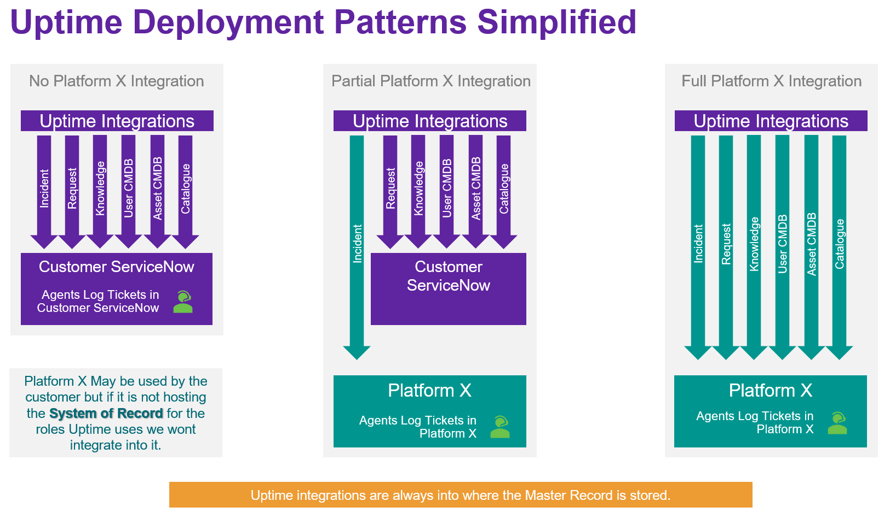
* Figure 1: UPtime Deployment Patterns

### No Platform X

* In this pattern is for customers who do not use ITSM roles on DXC Platform X platform as the System of record. For example, if the Service Desk log tickets into the Customer ITSM system and we ebond some of those into Platform X we still integrate into the Customer ITSM system NOT Platform X.

### Partial Platform X

* In this pattern the customer has some ITSM System of Record roles on Platform X and some on their own ITSM system. For example, our service desk operates within Platform X and it is the system of record for all incidents we will integrate UPtime into Platform X.

### Full Platform X

* This pattern is for customers who use all ITSM roles from the DXC Platform X Platform. For example, all the ITSM Roles are within Platform X, the customer ITSM Portal is the IT Connect Platform X portal.
* The intent of these deployment patterns is to provide sales and delivery flexibility as to how we sell and deploy UPtime. It must be recognized that the level of effort to deploy and run increases depending on the deployment pattern selected. The main effort areas are related to integrating into the Pltform-X or Customer ITSM platform and mapping / creating the data attributes required by UPtime where nessessarry. Efforts are underway in release 2+ to reduce the effort needed in deploying to customers.

**Note to SLA’s:** Integration with other ITSM solutions like SRA/Service Manager/SMAX/BMC Remedy, etc. will be considered as custom deployment options and need close collaboration with Offering team to evaluate the complexity, impact to deployment timelines and associated efforts, etc.

There are currently 3 planned releases for UPtime. Release one is currently available the chart below shows the projected release dates for the three deployment patterns.



* UPtime Releases and Roadmap
* Note: This product roadmap is intended to outline the general product direction. It is intended for information purposes only and may not be incorporated into any contract. The dates proposed are subject to change by DXC at any time.
* 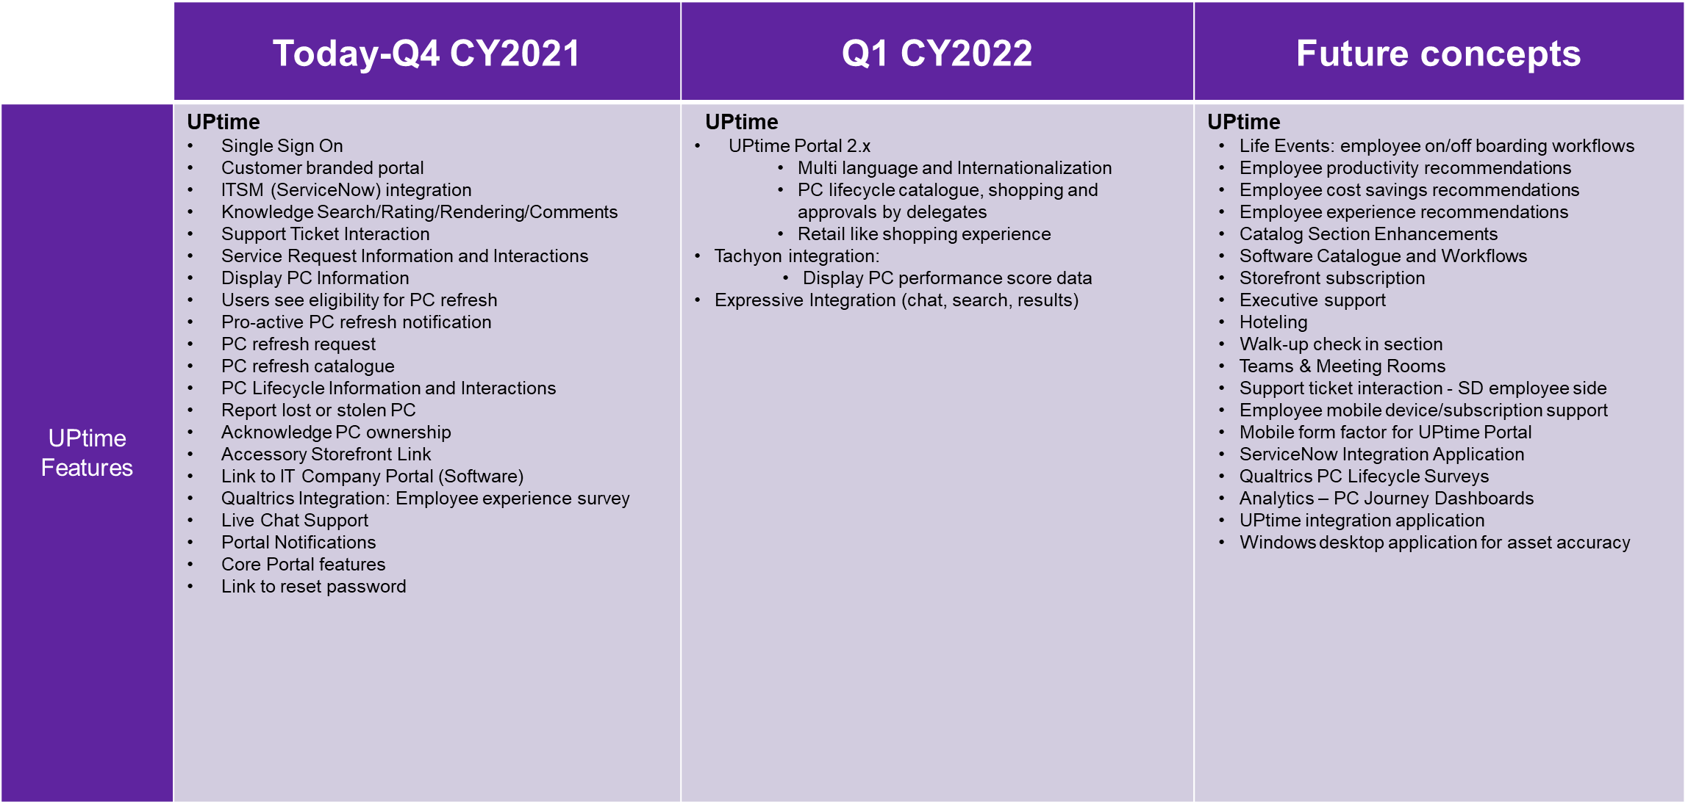

The below table list the releases (R1 / R2 / R3) with the features.



# Capability Mapping Checklist

* These lists help form the more detailed parts of each customer deployment pattern. Each section is broken into two parts
* Back End - These cover components such as cloud hosting, integrations, data, and analytics.
* Front End - These cover what the user sees and how they interact with UPtime.

**Note:** No content administration functionality hosted within the UPtime Portal. At this stage of development all content is controlled in the current source where the data resides (ServiceNow, DXC Gear, Company Portal, etc…) and configured to be accessible, viewable, and interacted within the Portal.

* Generic Areas

|  |  |  |
| --- | --- | --- |
| Back / Front | Capability | UPtime Solution |
| Back End | Azure Platform Hosting | DXC Managed Azure Subscription from CPS |
| Boomi Platform Hosting | Boomi Cloud hosting via DXC Managed Application Services or Secure Azure hosting |
| DXC Support of Service - Azure, Boomi, UPtime | Platform X Commercial or Platform X Dedicated |
| User CMDB System of Record (assets, region, email, language etc..) | Workday, Customer ServiceNow or Platform X |
| User Authentication | Okta or Microsoft Azure AD |
| ServiceNow Integration | Boomi connects to a ServiceNow Scoped Application |
| Notifications | Boomi connected with ASD & Microsoft 365 |
| Global Search | Customer ServiceNow or Platform X |
| Catalogue | Customer ServiceNow or Platform X |
| Telemetry Data Storage & Analytics | Azure Monitor, Azure hosted Databricks & Azure Blob Storage (Plus more) |
| UPtime Personalisation Data | Azure Cosmos DB |
| Front End | User Authentication | Okta or Microsoft Login Screen (or other SAML based Auth) |
| Portal for News, Outages, Approvals and Global Search | UPtime Portal |
| Notifications | UPtime Portal, Email, SMS |
| Portal Global Search (ITSM) | UPtime Portal |
| Catalogue | UPtime Portal pages for Services, Devices, Accessories, Software |
| User Survey and Sentiment | Qualtrics |
| Analytics Visualisations & XLA | Power BI |
| Multi Language Support | UPtime Portal |

* Device Management

|  |  |  |
| --- | --- | --- |
| **Back / Front** | **Capability** | **UPtime Solution** |
| Back End | PC Device Workflows | Boomi hosts templated & configurable workflows |
| PC Device Catalogue | Customer ServiceNow or Platform X |
| PC Device Request System of Record | Customer ServiceNow or Platform X |
| PC Device Notification Source | Customer ServiceNow or Platform X |
| PC Device CMDB | Customer ServiceNow or Platform X |
| PC Device Depot Services | Customer ServiceNow or Platform X |
| PC Device Asset Data Feed | Intune or SCCM feed into ServiceNow |
| PC Device Stock Management | Customer ServiceNow or Platform X |
| PC Device OEM Integration | Boomi and Customer ServiceNow or Platform X |
| PC Device Telemetry & Automatic Fix | 1e Tachyon or Systrack or Nexthink or Microsoft |
| Front End | PC Device User Catalogue | UPtime Portal |
| PC Device User Notifications | UPtime Portal, Email, SMS |
| PC Device Information | UPtime Portal |

* Support

|  |  |  |
| --- | --- | --- |
| Back / Front | Capability | UPtime Solution |
| Back End | Incident Process and System of Record | Customer ServiceNow or Platform X |
| Knowledge Base Content | Customer ServiceNow or Platform X or Espressive Barista |
| Knowledge Search | Customer ServiceNow or Platform X or Espressive Barista |
| Service Desk Agent Chat System | DXC Agile Service Desk (Amazon Connect) |
| AI Chatbot | Espressive Barista or ServiceNow Agent |
| Request Automation | Boomi or ServiceNow |
| Approval Workflow | Boomi or ServiceNow |
| Front End | ITSM User Notifications | UPtime Portal, Email, SMS |
| ITSM Portal for Knowledge, Incident | UPtime Portal |
| User Chat Interface | UPtime Portal Web Chat, Microsoft Teams |

# UPtime Services-Initial Release/R2 - WIP

* Below diagram illustrates the **UPtime Release 2.0** Features
* 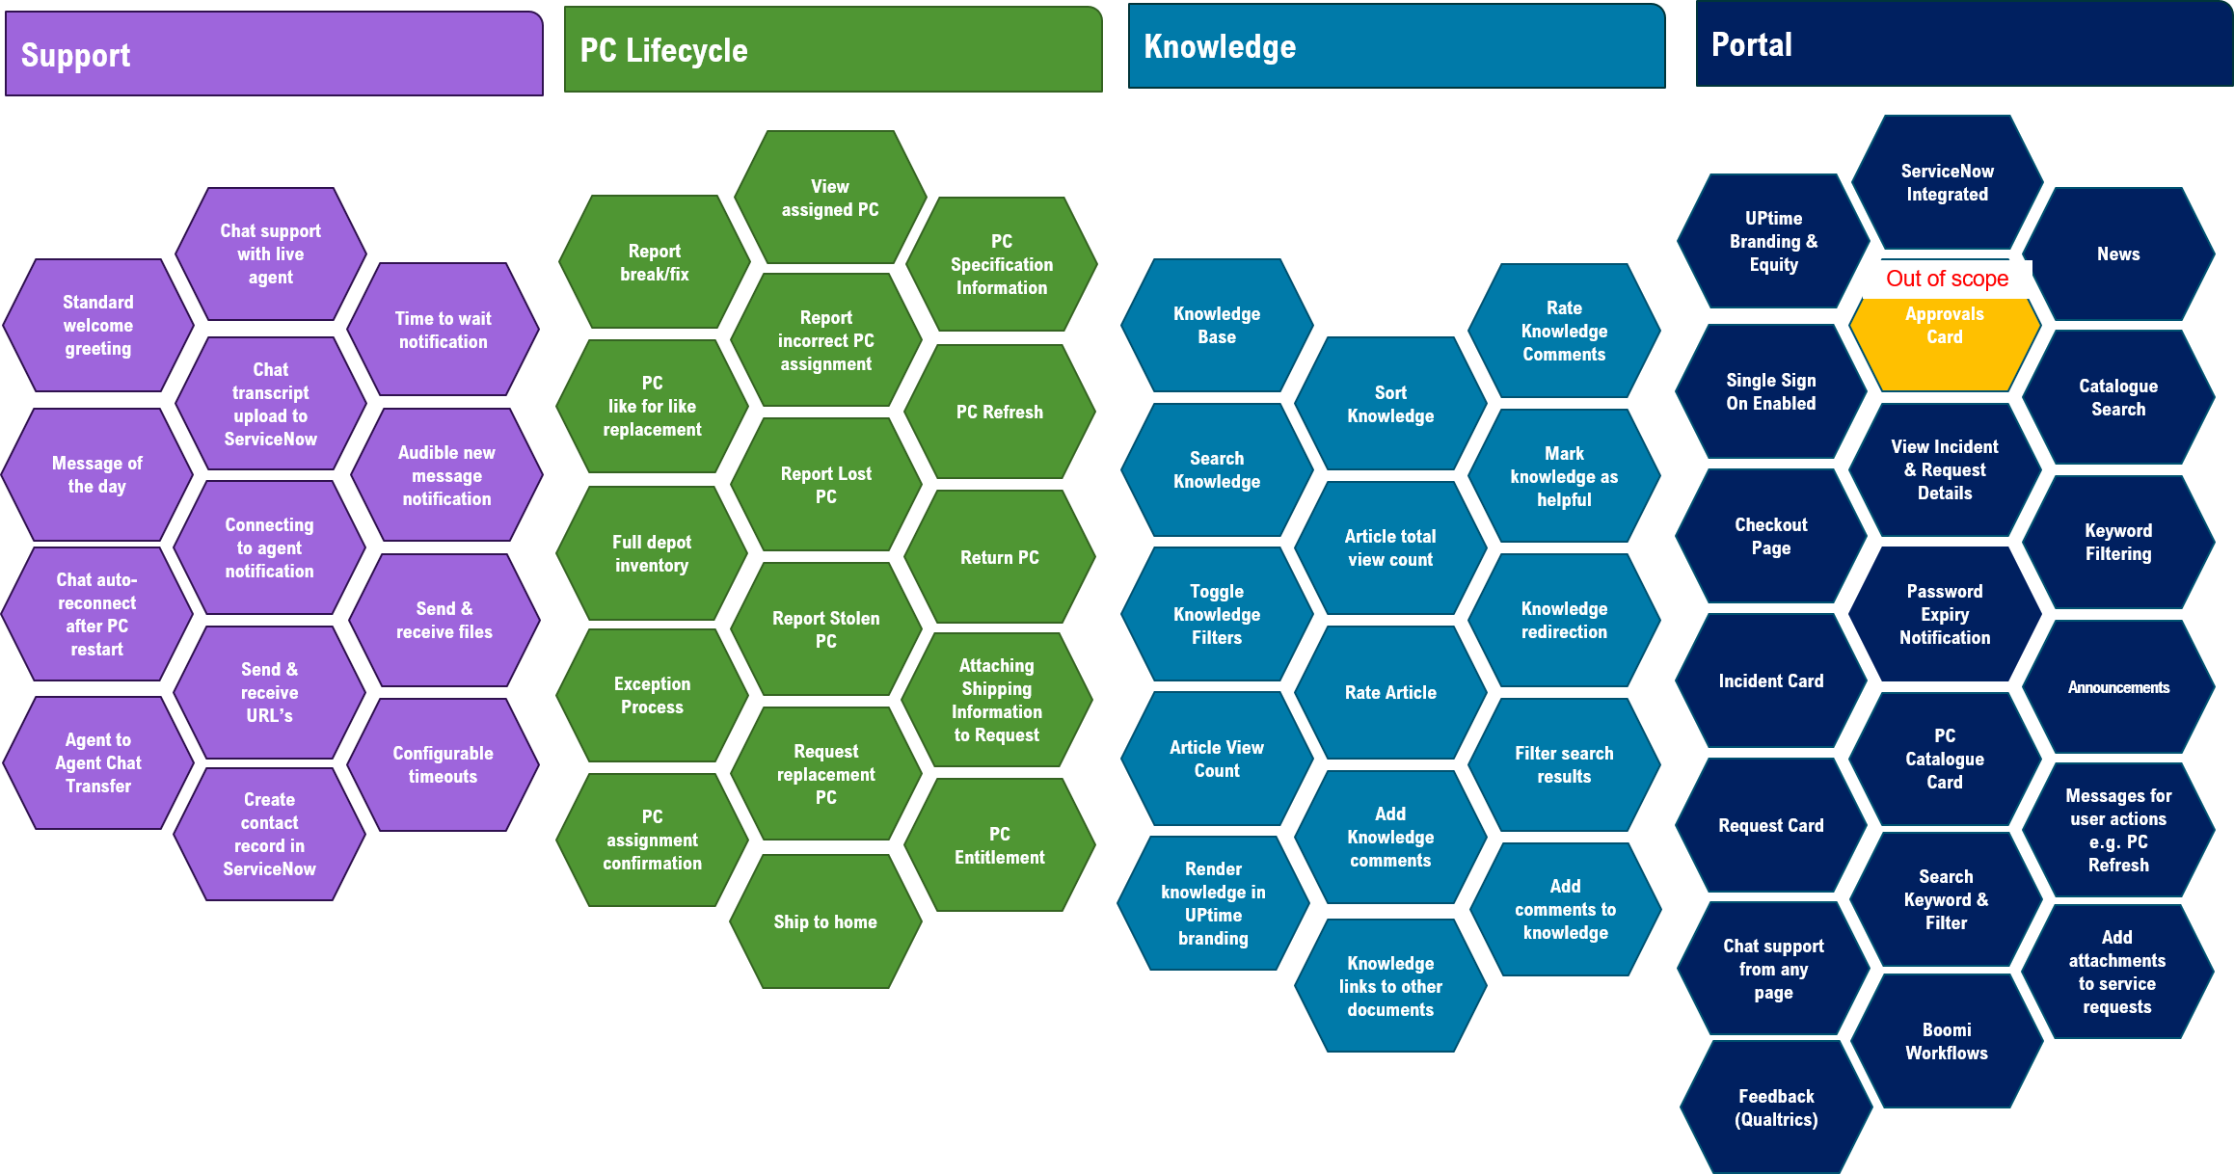

|  |  |  |
| --- | --- | --- |
| **UPtime Components Quick Reference** | | |
| **Service** | **Description** | **Link** |
| **General** | | |
| SAML based Authentication / Single Sign On |  | Go To |
| Standard welcome greeting |  | Go To |
| Message of the day |  | Go To |
|  |  |  |
| **Portal Services** | | |
| News / What’s New |  | Go To |
| Announcements |  | Go To |
| Search Keyword & Filter |  | Go To |
| View Incident & Request Details | Ability to interact with support tickets (add comments etc.) | Go To |
| Password Expiry Notification | Notify when the password is going to expire, so that users can change it | Go To |
| Chat support from any page |  | Go To |
| Incident Card |  | Go To |
| Request Card |  | Go To |
| Add attachments to service requests | Ability to send/receive attachments, view/upload attachements to the Incident record | Go To |
| PC Catalogue Card |  | Go To |
| Catalogue Search |  | Go To |
| Feedback (Qualtrics) |  | Go To |
| **Support** | | |
| Chat auto-reconnect after PC restart |  | Go To |
| Agent to Agent Chat Transfer |  | Go To |
| Chat support with live agent |  | Go To |
| Chat transcript upload to ServiceNow |  | Go To |
| Connecting to agent notification |  | Go To |
| Send & receive URL’s |  | Go To |
| Create contact record in ServiceNow |  | Go To |
| Time to wait notification |  | Go To |
| Audible new message notification |  | Go To |
| Send & receive files |  | Go To |
| Configurable timeouts |  | Go To |
| **Knowledge** | | |
| Knowledge Base |  | Go To |
| Search Knowledge | Ability to search against a Knowledge Base | Go To |
| Toggle Knowledge Filters |  | Go To |
| Article View Count |  | Go To |
| Render knowledge in Uptime branding | Render Knowledge Article content for Users to see | Go To |
| Sort Knowledge |  | Go To |
| Article total view count |  | Go To |
| Rate Article |  | Go To |
| Add Knowledge comments | Ability to interact with Knowledge Articles (add comments etc.) | Go To |
| Knowledge links to other documents |  | Go To |
| Rate Knowledge Comments |  | Go To |
| Mark knowledge as helpful |  | Go To |
| Knowledge redirection |  | Go To |
| Filter search results |  | Go To |
| Add comments to knowledge |  | Go To |
|  | Present Users with feature knowledge content | Go To |
| **PC Lifecycle** | | |
| Report break/fix |  | Go To |
| View assigned PC |  | Go To |
| PC Specification Information |  | Go To |
| PC like for like replacement |  | Go To |
| Report incorrect PC assignment |  | Go To |
| PC Refresh |  | Go To |
| Full depot inventory |  | Go To |
| Report Lost PC |  | Go To |
| Return PC |  | Go To |
| Exception Process |  | Go To |
| Report Stolen PC |  | Go To |
| Attaching Shipping Information to Request |  | Go To |
| PC assignment confirmation | Acknowledge PC assignment | Go To |
| Request replacement PC |  | Go To |
| PC Entitlement |  | Go To |
| Ship to home |  | Go To |

* UPtime engagement portal acts as a user front end for engaging the user for support, knowledge articles will be incorporated into the Self Help and Self Heal channels. Initial release (R2) of UPtime provides the portal interactions using a new User Experience. This includes some base features including
* Act as a user front end for engaging the user for support, knowledge articles will be incorporated into the Self Help and Self Heal channels.
* Scalable, secure UPtime employee portal running in Azure cloud, rebranded to client, provided as a service.
* User configurable notifications (outages, service requests, status changes, etc.)
* The UPtime Portal is accessible via native web browsers and is optimised for mobile/tablet use.
* DXC services to continuously optimize the environment for better user experience and cost optimization.

### General Services

#### Portal Branding Customisation

* The release 1 portal branding customization is limited to the following.
* The logo and company name in top left-hand corner
* The colour scheme of the background
* The colour scheme of the card types
* 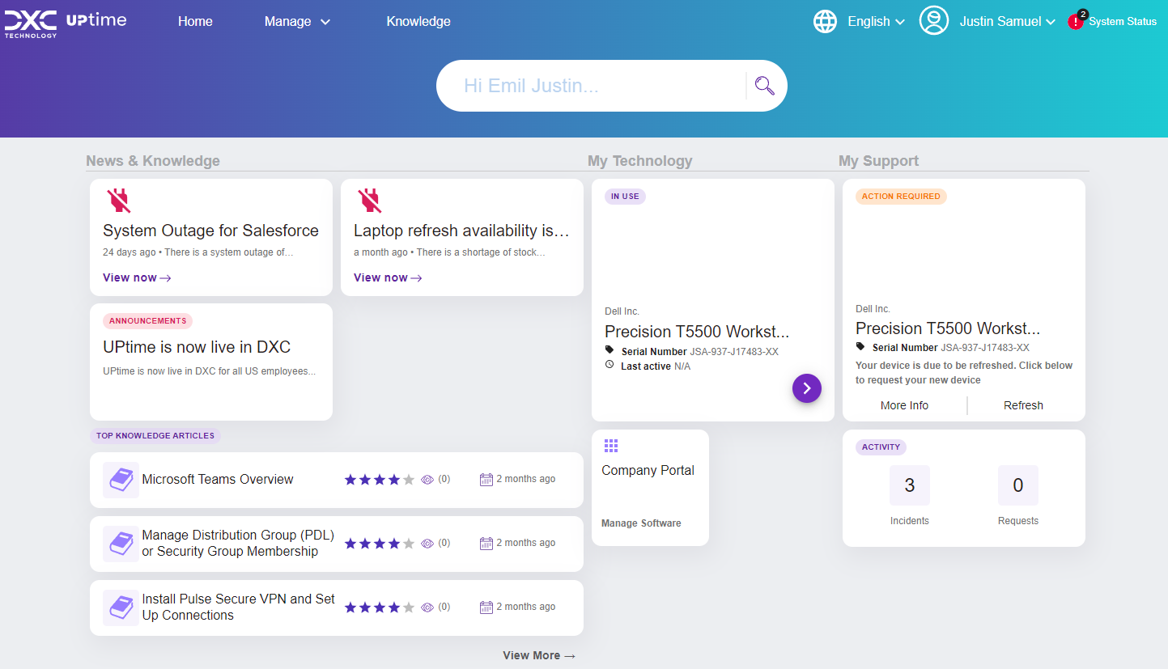

#### Regional Settings

* Users will see regional content such as the local phone number for the contact center.

#### Customised Notifications

* Users will continue to be notified about major PC Refresh stages by means of email notifications. The Portal will guide the user through the process through cards displayed in the “What’s New” portal section, and through indicating the status of the PC assigned to them in the “My Stuff” portal section.

#### SAML based Authentication / Single Sign On

* UPtime can integrate with most industry standard authentication system (e.g., Active Directory, AzureAD, ADFS, SailPoint, OKTA, PingID, etc.). Authentication will be based on integrations into the customer SAML based authentication systems. Users will be prompted for Authentication prior to accessing the Portal.
* For Initial Release, UPtime will be integrated OKTA as authentication and authorization platform as well for Single Sign On.
* Users will be able to access the Portal through Microsoft, Google, and Apple web Browsers.
* Authentication will be based on integrations into the customer SAML based authentication system such as, Azure Active Directory, Ping etc.

**Note:** Other SAML authentication mechanisms will be added with future releases. SLAs to validate/qualify current authentication and authorization solution in place and its integration with UPtime. Reach out to offering team for support.

### Portal Services

#### News & Knowledge

* UPtime will be integrated with ServiceNow/ITSM display to provide important announcements for the IT environment.
* Any Outage articles are shown in the What’s New section at the top of the Portal.
* Users are presented with a card at the top of the page
* The Uptime solution provides these interactive technologies which codify the employee user journeys and use cases across all service towers

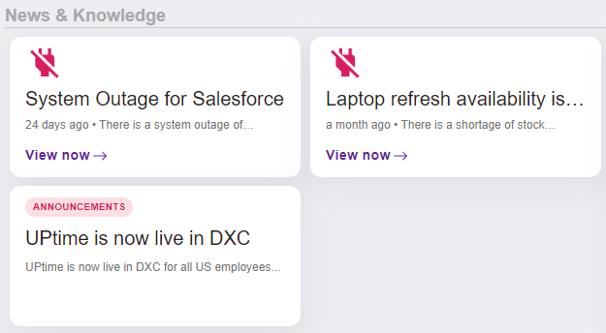

#### Device Information

* Users can see all the assets assigned to them with and manage devices they are responsible for. When you click on the device/model, it will take you to the Device Details page. Users can perform below activities with the assets/devices assigned to them.
* 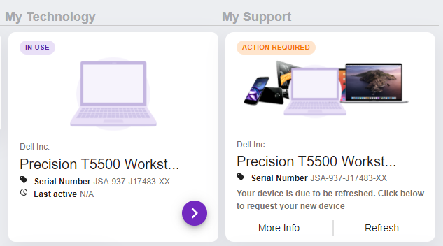
* It is integrated with ServiceNow/ITSM to retrieve asset information, such as asset tag, status, model, image, process state, etc, as well as verify whether asset is eligible for refresh or not.

UPtime queries the DXCI ServiceNow tables using the Table API to retrieve asset information and its related information.

* UPtime retrieves asset information to present the list of assets for multi purposes in the Portal, such as retrieving the list of current user's assets, what asset can be refreshed, raising incident or making a request related to their assets, etc.
* Asset API > Azure Storage UPtime download the image of model from DXCI ServiceNow and then upload it into Azure storage. UPtime retrieve the image of model for presenting in the list of assets in the Portal.
* Asset API > Azure Cosmos DB UPtime retrieve configuration from Azure Cosmos DB to apply some setting configured in API. UPtime retrieve the api configuration to make some filter or do some actual actions in the Portal. e.g. retrieve the image of model, verify whether asset is eligible for refresh based on configuration
* Asset API > Azure Redis Cache Internally the service will keep a Redis cache for a quicker access to previously accessed users. If the value is not present in Redis an external call is made to the Service Now/Cosmos database to fetch (and update the cache) the latest order information. Accessing from cache is to enhance performance and reduce the time accessing data to server.

#### Password Reset Reminders

* Users will get a “Password Reset Countdown Card” notification based on their password exipiration date. These notifications will provide the user with a countown to their password reset date and a link through to the password reset system.
* This has two configurations.
* API call from UPtime to the password management solution to retrieve the expiration details for the user at login time.
* URL configured to the customers password reset page.
* For release 2 this integration will be into Okta.

### Support Services

#### Support Ticket Interaction (Existing Ticket)

Incident Interactions

* Users are presented with their most recently updated ticket in the What’s New section at the top of the Portal.
* Users can view their active Incident/RITM tickets.
* Users can view their resolved Incident/RITM tickets.
* Users can view their closed Incident/RITM tickets.
* Users can view their ticket history.
* Users can open more details about a Ticket.
* Users can add comments to an open Ticket.
* Users can Search tickets

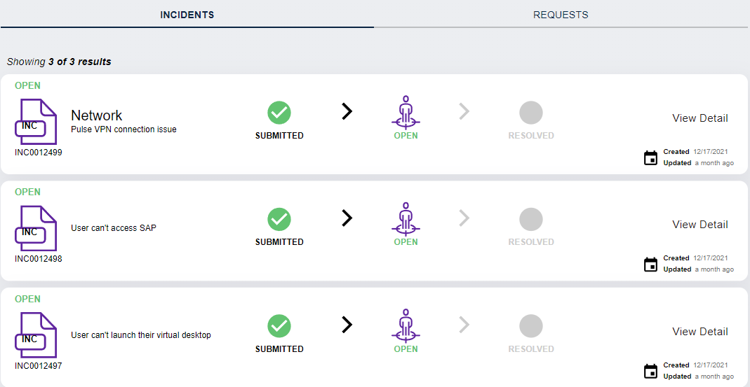

#### Support Chat

* Within the portal there is a link to the chat system.
* This can link to the Chat Support through Teams.
* The contact center will be in Agile Service Desl (Amazon connect)
* Users can get the phone number to get Voice Support
* 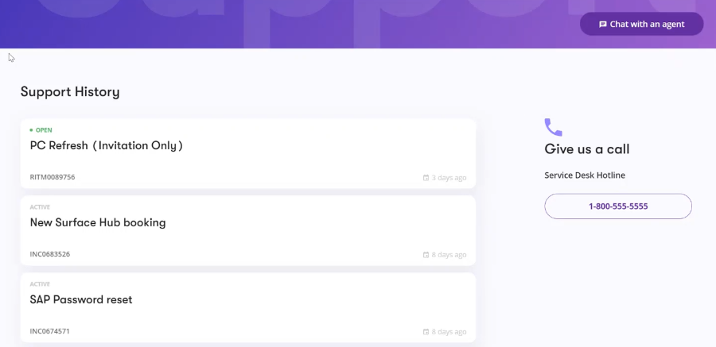

#### Web Chat

* Live Support Chat Link - A link to Live Support Chat with the Service Desk. This component is visible on every page of the UPtime Portal.
* Live Chat Support through the Portal - Users can chat with a Service Desk agent through the UPtime Portal. User should be able to initiate a chat with an agent from the Portal.
* Allow for chat timeout limits to be set as a configuration. Authorized service desk leads should be able to configure settings of chat tool
* Web Chat will be provided as channel through to the service desk. This can be used with the Microsoft Teams based chat however these chats are not Omnichannel. This means a chat through Teams is fully independent to a chat happening through the portal.
* Live Chat Support through the Portal - Users can chat with a Service Desk agent.
* Allow for chat timeout limits to be set as a configuration
* Ability to consume outage messages when you begin chat (before user enters the chat queue)
* Ability to send outage message whilst user is waiting in a chat queue
* User should see a message of ongoing outages when a chat is initiated. Should be an upfront message that does not require end user to enter the queue or type something first.
* Customised welcome message in the chat when a user begins
* Audible notifications presented to user when there is a conversation in chat (e.g. new message typed by agent) - configrable (turn on / off)
* Ability to re-connect to the same chat session after a reboot
* UPtime Release 2.0 Features
* Ability to send attachments to the agent/ Ability for the agent to send an attachment to the user"
* Both agent & user can send attachments to each other via the chat window with limits on the size, and file type. (20 MB and pdf and office files only)
* Users can view any attachments that have been uploaded to the Incident record in the Attachments section. This includes the name and size of the file. Users can see all interactions with the Incident record that create events, e.g. Ticket Creation, Attachment Uploads etc.
* Attachment Uploads - Users can upload attachments to the Incident record. This attaches the file and generates an "event" in the activity section. User can upload files to the incident record through an incident detail page (separate from sending a file through an active chat window to an agent)

#### Software Catalogue

#### Link to Intune Company Portal (Software)

* 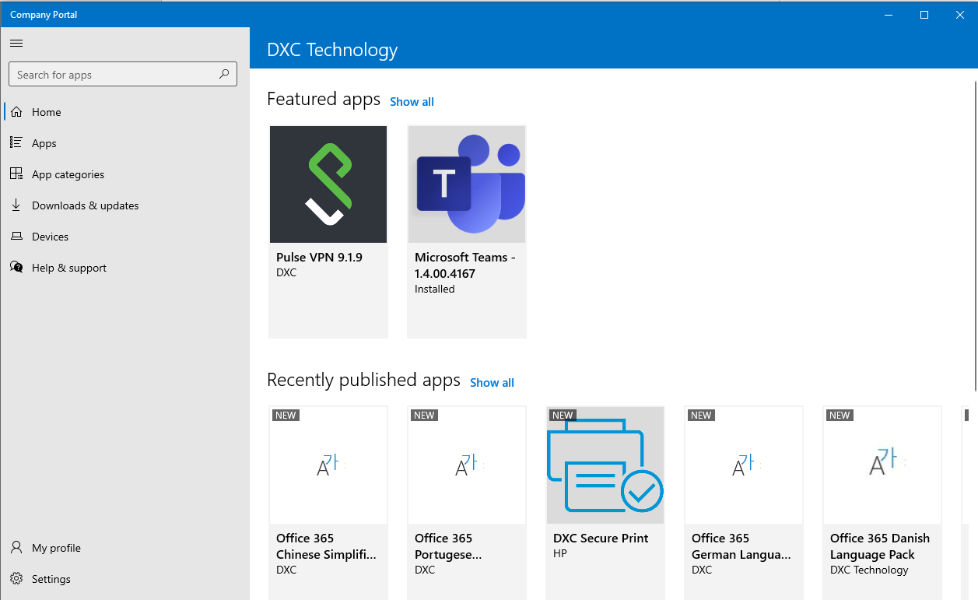This portal link triggers the [Intune Company](https://www.microsoft.com/en-gb/p/company-portal/9wzdncrfj3pz?activetab=pivot:overviewtab) portal to open on the users device where they can select and install software that has been made available to them.
* If the customer does not have company portal, we can re-direct the link to a customers Software store or turn the link off.

#### Multi Language Support

Current version of the portal supports the English language. Subsequent versions (see Roadmap) will support other languages. The support for specific languages will be determined based on client demand. This will include Right-to-Left (RTL) languages.

#### OEM integration

* The DXC UPtime Portal will act as a front end for engaging the employees for device management services with an end-to-end device lifecycle process that is simple, convenient for users and personalized. The device lifecycle process is automated via OEM vendor integration with the ServiceNow instance. This generates a workflow for the fulfilment, break-fix, re-deployment or decommissioning of a device.
* DXC partners with OEM vendors and developed a pre-defined OEM Vendor integration framework with selected providers, we can also develop custom integrations with other supplier and distributors.
* Below Diagram showcase an overvierw of OEM (HP) integration framework as a reference.
* 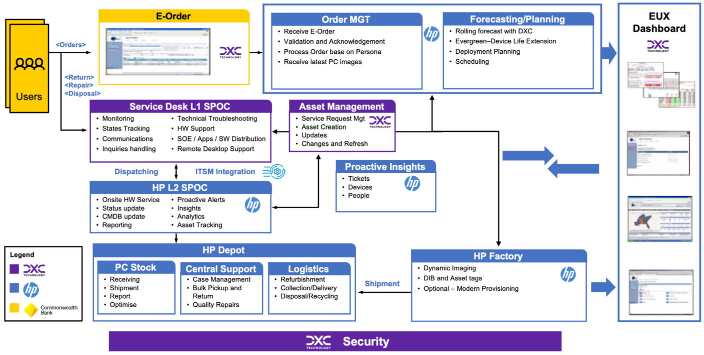
* Figure 2: OEM (HP) integration framework

### Knowledge Services

#### Knowledge Search

* With the UPtime, end users can browse knowledge articles to solve their own issues—without getting a technician involved and empowers users to resolve their own issues, increasing user satisfaction. The self-service engagement platform can be configured to match organization’s brand to provide an interface that looks and feels familiar—a key factor influencing self-service adoption.
* DXC uses API technology to integrate knowledge management capabilities between customer ITSM platforms and DXC’s UPtime. DXC uses Microservice technology to integrate as a standard approach to connect with the various tables in the ITSM environment. The main integration functions are listed below.
* UPtime retrieves knowledge and knowledge feedback for presenting the Knowledge and feedback information at the time they view it in the Portal and comment feedback on the Knowledge item.
* Search for knowledge using the end point ITSM search capability under the context of the user performing the search
* Return knowledge articles and their content, including attachments
* Provide knowledge article feedback; if an article is useful, rating and comments
* Update knowledge article view counts

In addition to the above main functions, DXC can integrate the follow capabilities.

* Knowledge announcements for display in UPtime
* Display relevant top and featured knowledge for a user

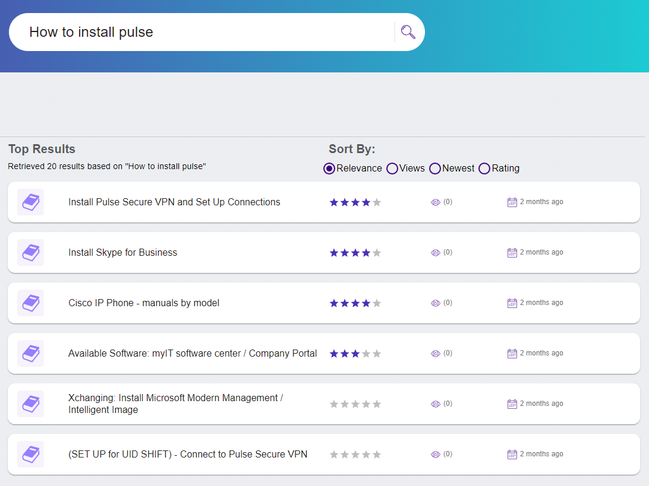

* UPtime consolidates multiple knowledge sources into a single knowledge base, so that users (both end users and technical) can quickly find relevant information. UPtime can be integrated with the Knowledgebase that is stored within ServiceNow and can provide the below features:
* Users can search a Knowledge Base using the search bar.
* Users can view Knowledge Articles in detail in a Knowledge Article Detail page.
* Users can view comments, add new comments and rate Knowledge Articles.
* Users can view “top 10” Knowledge Articles
* Personalised search option

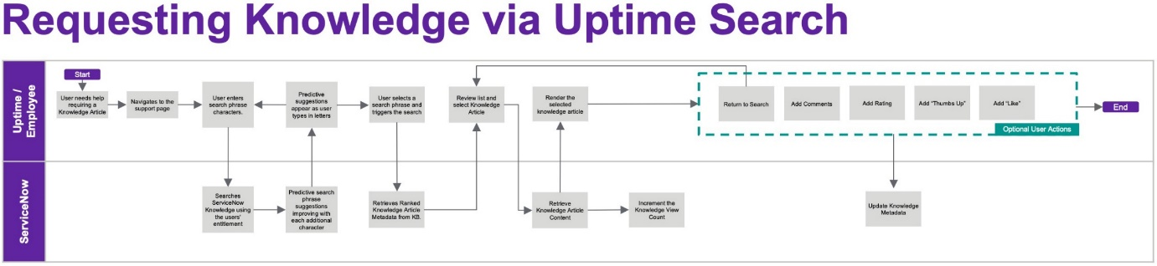

* Additionally, UPtime integrated with the Knowledgebase can provide the below features:
* Knowledge Integration Configuration 1 - Global Search

This configuration is a simple “service account” based method of searching the ServiceNow knowledge. This requires no additional configuration within ServiceNow but will return a generic set of search results based on the service integration account.

* Knowledge Integration Configuration 1 – “On Behalf of” Search

This configuration requires additional changes to the ServiceNow integration. For Platform X integrations these will be available without extra effort. For customer deployments we will provide an “update set” which will need installing in the customer ServiceNow instance. The key difference here is that this search will return results using the individual users’ privileges filtering out things they may not normally see.

### PC Lifecycle Services

#### PC Workflow

* PC Workflow leveraged from within the ServiceNow platform used by the customer. If the customer does not have any PC workflow it will be added as part of the T&T delivery. If the customer is on Platform-X they will use the standard PC Workflow that is already deployed.

#### PC Lifecycle Workflow

* The DXC UPtime Portal will act as a front end for engaging the employees for device management services with an end-to-end device lifecycle process that is simple, convenient for users and personalized. The device lifecycle process is automated via OEM vendor integration with the ServiceNow instance. This generates a workflow for the fulfilment, break-fix, re-deployment or decommissioning of a device.
* DXC partnered with selected OEM vendors and developed a pre-defined OEM Vendor integration framework. We can also develop custom integrations with other supplier and distributors as necessary.
* Acknowledge Device/Asset Ownership
* Report Ownership Error (correctly / incorrectly) assigned to me
* Report Missing Device
* Refresh Device
* Report Broken Device with the help of an agent
* Request for a refresh if eligible
* Return Device / Already Returned
* Report as lost of stolen
* **Orders & Incidents** - The Orders & Incidents feature within UPtime Portal is where users navigate to view and manage their orders (from the catalog and against existing assets) and incidents. The feature gives users access to
* Orders & incidents they have placed for themselves
* Have placed for others
* Have had placed for them by others

**Approvals** - Users that are marked as an approver on an order utilize the Approvals feature to view and manage their approvals.

Refer to the Workflow Diagrams / Flow Charts related to Device Life cycle here PC Device Lifecycle.

#### PC Refresh Request

For PC Refresh request using UPtime, Users are presented with;

* Assigned devices.
* Notification card when their Device is due for a refresh/upgrade.
* A card showing devices that are to be returned.
* A Knowledge Article showing the Refresh process when they request a refresh device.
* A link to Intune to manage their software.

#### PC Request Device

Request Device request using UPtime,

* Users are presented with a set of “devices” that can be ordered.
* Users can view details of each device.
* Users can request a device refresh that matches their device profile if they’re entitled to a refresh.
* Users can link to request an exception for a device refresh that doesn’t meet their profile.

#### Accessories Catalogue

* Accessories catalog encompasses IT peripherals that usually complement and support employee use of core hardware like Computers and Mobile phones. This catalog offers optionality per tenant to broadly cover what the given customer considers an Accessory, but mostly focuses on the following categories:
* Adapters & Cables
* Docking Station
* External Drive
* Headset/Speakerphone
* Keyboard/Mouse
* Monitor
* Other
* UPtime portal will have a link to the source for IT accessories catalogue that you need to work effectively. Users depending on their needs, can choose from the available accessories catalogue and order equipment, like Keyboard, Mouse, Monitor, Headsets, or a speakerphone.
* Note: For DXCi, this links to DXC Gear (<https://gear.dxc.com/>).

#### Request on behalf of

* By searching for and selecting another user the request is raised on behalf of that user. Manager approval (when required) will be sent to the requested for persons manager. This is useful to order a PC for a new hire.

### Reporting and Analytics

#### Portal Analytics

* Portal Usage analytics - Analytics are made available via an API which can be consumed by a BI system such as Power BI.
* Analytics will include
* Page views
* Top pages
* When users use UPtime.
* Where users consume UPtime (county locations)
* Repeat users

#### PC Lifecycle Analytics and XLA

* Establishing a Proactive Workplace Operations Centre to drive continuous service improvements. DXC will utilise Predictive Analytics & Customer Experience Tooling to monitor, manage and report on the Customer managed devices. Using this approach, DXC will provide:
* – Remote diagnostics - Faster incident resolution resulting in increased user productivity through reduced downtime.
* – Automation – Providing proactive and predictive management of the environment to uncover and remediate more issues before they become a problem resulting in a reduction of incidents
* – End-User Experience improvement – Monitoring, managing and trend analysis of the end-user experience facilitating the identification and qualification of future improvements
* The solutions will be applied pro-actively, wherever possible, to limit user disruption and maintain a positive service outcome. DXC will analyse device data to develop root-cause-analysis of problems and implement resolutions to continuously optimise devices and improve user experience

1. **Technical architecture diagrams**

A series of architectural documentation describing the different components of UPtime, the different integrations, and the underlying services each component is made from.

This section outlines the high-level architectural patterns that are followed where possible throughout UpTime.

Disclaimer: UPtime Design documentation. The designs are accurate for the current initial release and subject to change.

* Uptime Development Environment

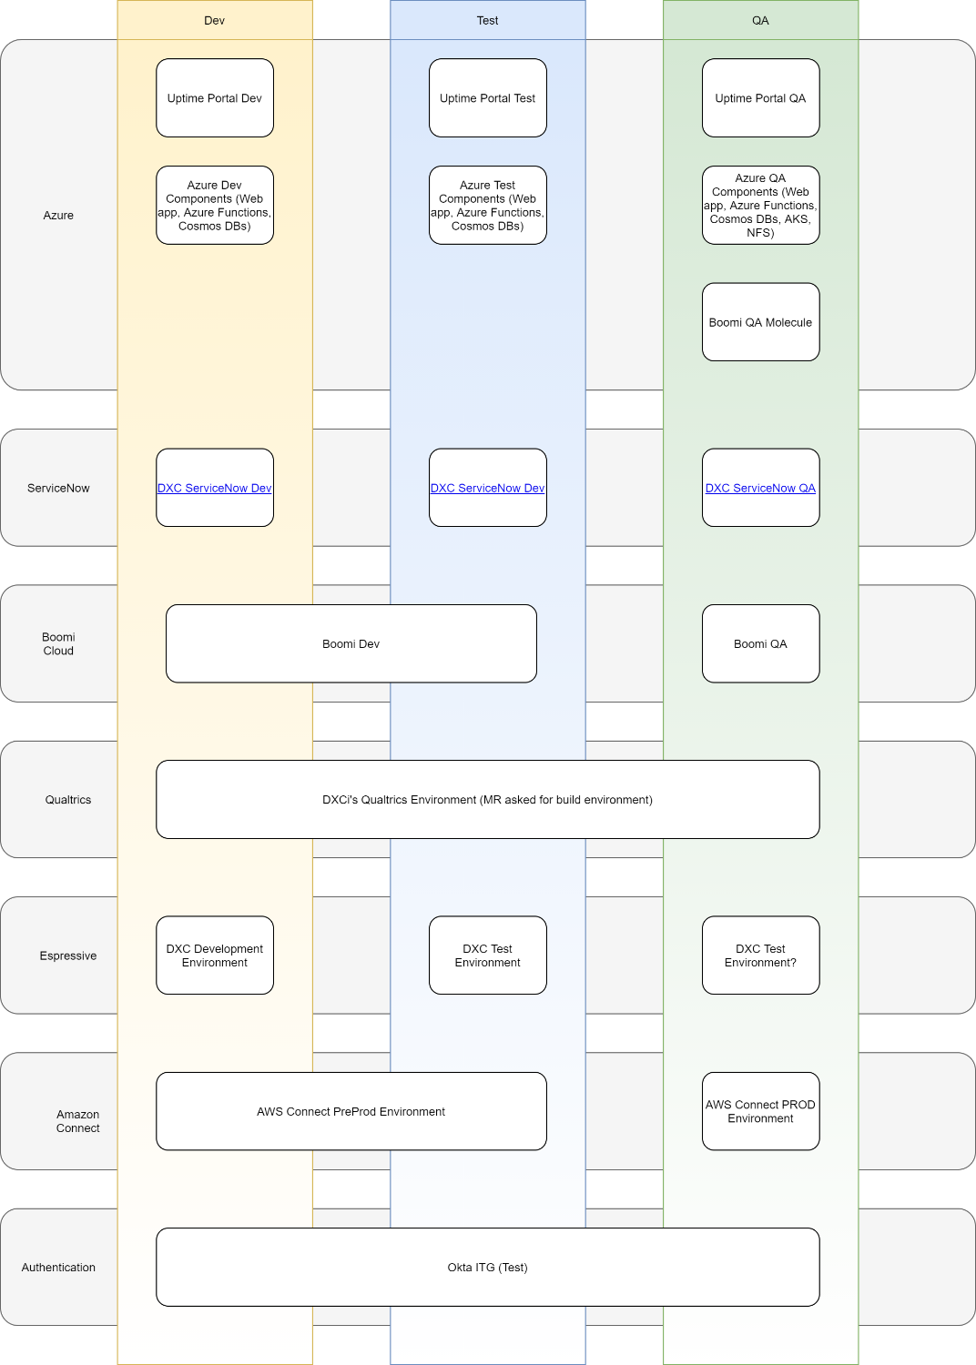

* UPtime High Level Architecture

Diagram

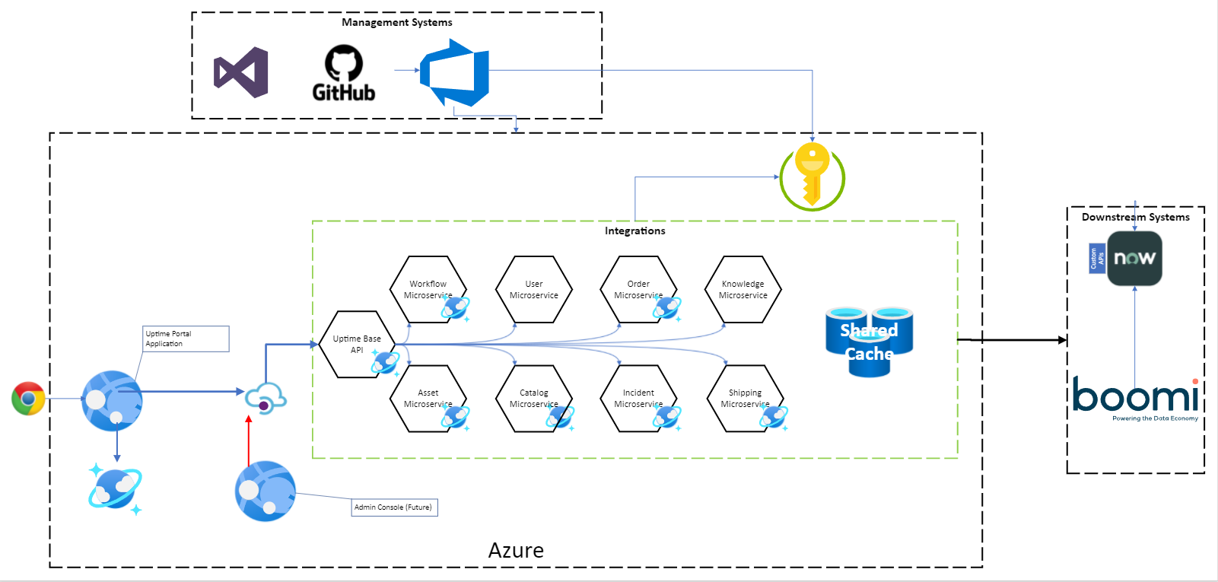

### Integration Patterns

### Front End / Back End split

UpTime is split into 2 sections - Front End and Back End.

* The Front End is composed of an End User portal that's accessible by Users over the internet. This is the presentation layer.
* The Back End is composed of multiple integration services that facilitate the retrieval of data and the performance of actions against downstream systems

As a rule, any integrations that the Front End requires must go through a Back End service.

Backend / Frontend split. Front End Portal is a consumer. Where possible, configurations and policies/rules are defined in the backend APIs for the Front End to consume. Front end is there to interpret and display backend processes

Where possible, Workflow and processes are defined in Boomi and are considered DXC IP

DXC managed infrastructure is used to host where possible

Microservice and API breakdown and patterns. API first development

* UPtime Azure Architecture
* 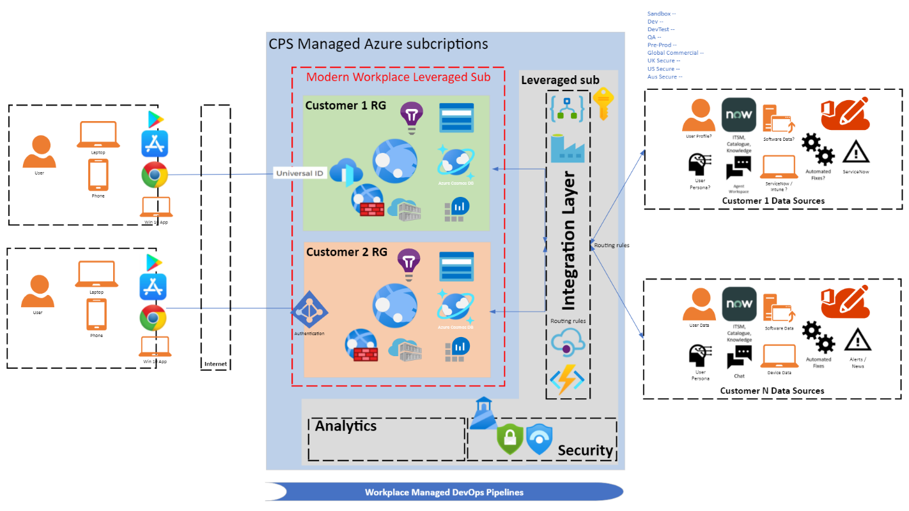
* UPtime provides a scalable, secure engagement portal running on cloud service providers like Azure to host the portal services as well other partners supporting the client. It is assumed that Azure Platform is managed by DXC’s CPS team and is bundled into the Price per user.

**Note:** SLAs to co-ordinate with Account/Delivery/CPS team proposed configuration as part of client on-boarding activities.

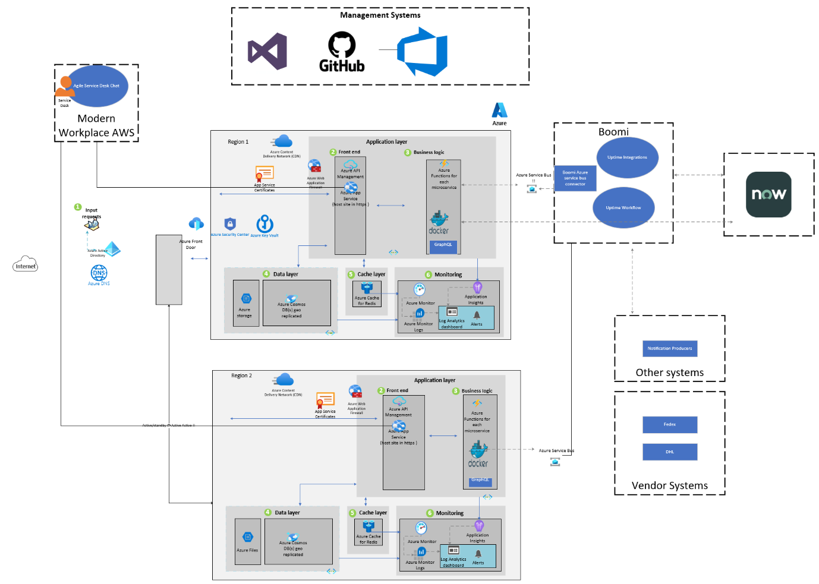

* UPtime Data Analytics Architecture

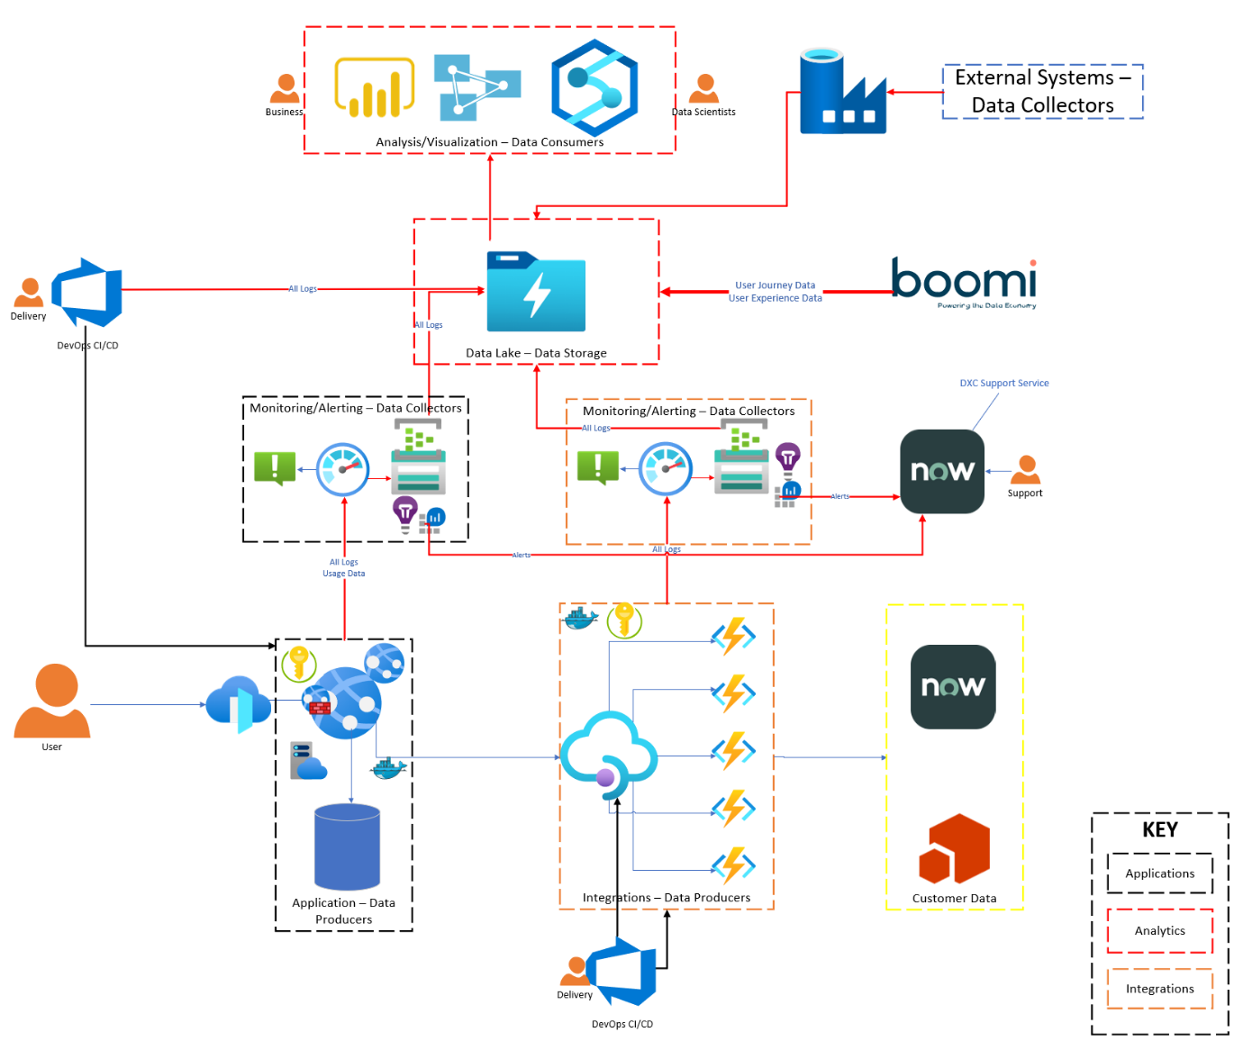

* UPtime Notification Design

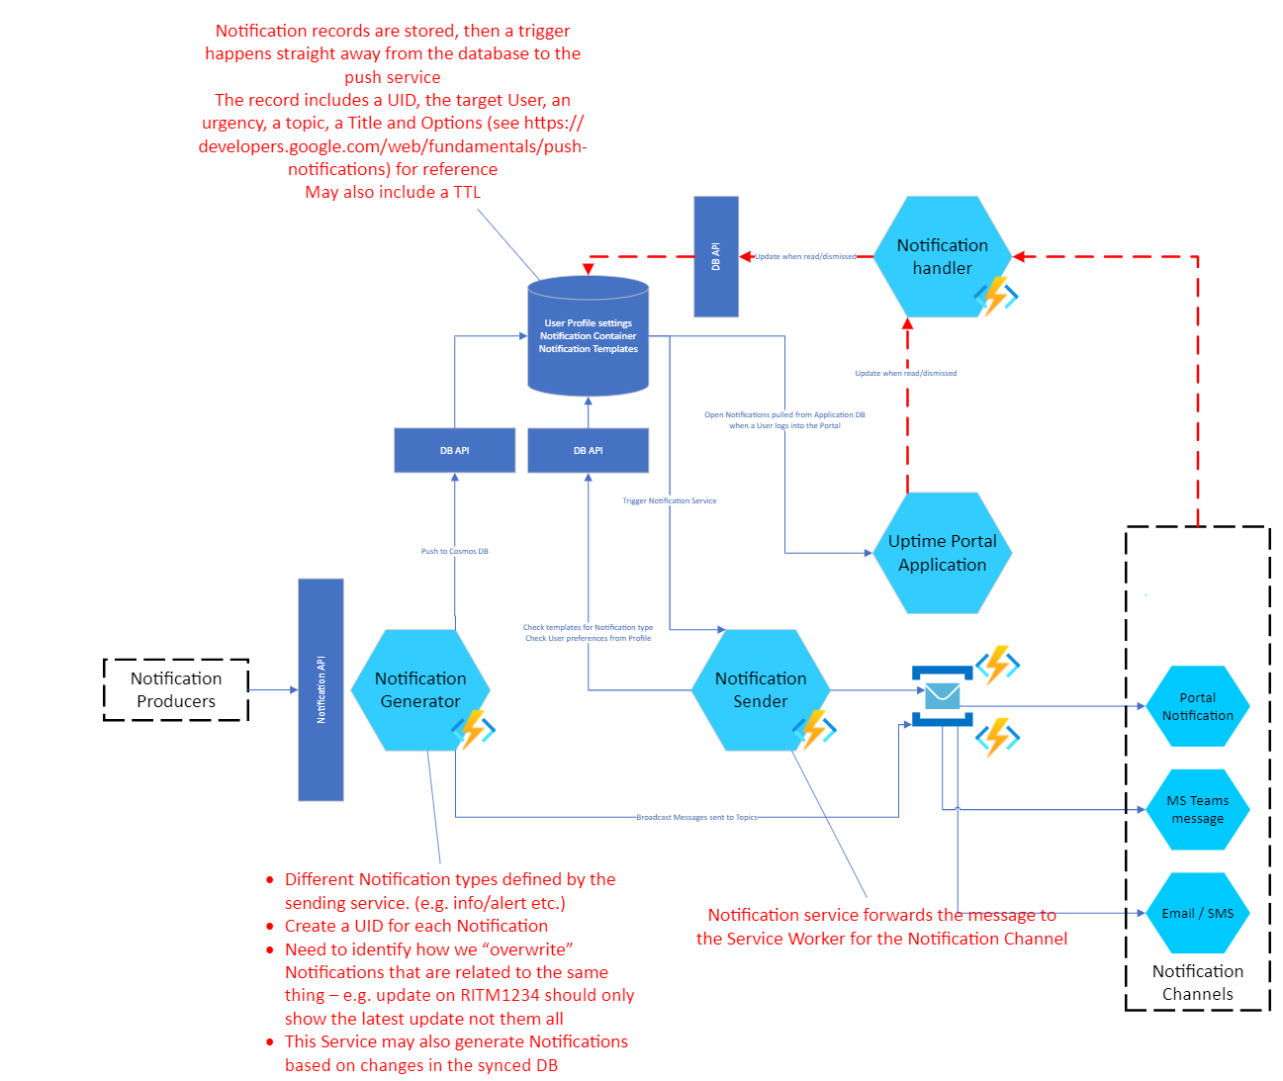

* UPtime Microservices Architecture Overview

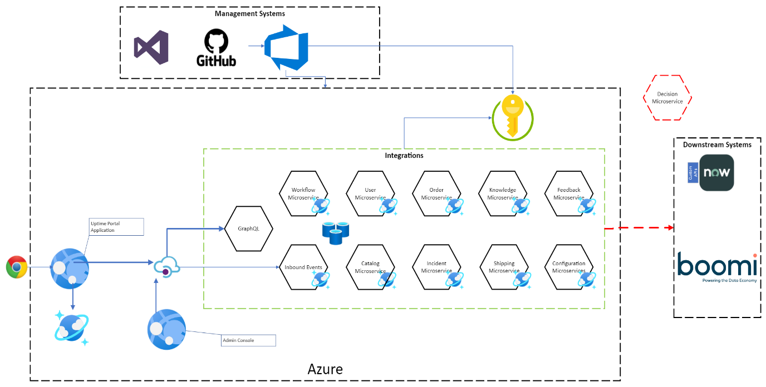

# UPtime Bill of Materials (BOM) & Procurement

* UPtime is DXC’s approach to providing fully integrated and automated Modern Workplace services to its customers and to increase the overall value of Modern Workplace services by combining Automation, Analytics, and Intelligence.
* This section covers the Bill of Materials (BOM) & Procurement process.
* Bill of Materials (BOM)

|  |  |  |  |  |
| --- | --- | --- | --- | --- |
| * Product Description | * Phase * (Build / Ongoing) | * Billing Cycle | * Purpose | * Quantity |
| * Setup Azure services for UPtime – CPS | * Build | * One-Time | * Spinning up Azure Services for UPtime via DXC Managed Azure Subscription from CPS | * Per Client Instance |
| * Client allocated Azure service subscriptions - CPS | * Ongoing | * Monthly | * Capacity for clients’ UPtime environment | * Azure Monitor, Azure hosted Databricks & Azure Blob Storage Azure Cosmos DB, (Plus more)… |
| * Qualtrics XM Setup | * Build | * One-Time | * Setup Real-time employee engagement insights and action planning | * Per Client Instance * Vendor Assistance and Implementation |
| * Qualtrics XM licenses | * Ongoing | * Monthly | * Licenses for XM Services | * Base Services * Add-On Services * # of Users/Devices |
| * Qualtrics XM Vendor Support | * Ongoing | * Monthly | * Vendor engagement model, included in the per license costs | * Vendor Assistance during Delivery with support requests and escalations, |
| * Dell Boomi Support | * Build | * One-Time | * Design/Build API Integration, Connectors and Workflows into SerrviceNow and other System of records | * Base: API’s/Workflows/Connectors * Add-on: Change Control Process |
| * Dell Boomi license | * Ongoing | * Monthly | * API/Workflow support | * API’s/Workflows * Add-on: Change Control Process |
| * Espressive Barista Setup | * Build | * One-Time | * AI based virtual support setup | * Per Client Instance |
| * Espressive Barista License | * Ongoing | * Monthly | * AI based virtual support agent | * Per Virtual Chat |
| * 1E Tachyon Installation Services | * Build | * Monthly | * Endpoint measurement | * Per Client |
| * 1E Tachyon Platform | * Ongoing | * Monthly | * Endpoint measurement | * Per Client |
| * 1E Tachyon Client Licenses | * Ongoing | * Monthly | * Endpoint measurement | * # of Devices |

* Procurement process

|  |  |  |  |
| --- | --- | --- | --- |
| * Product Description | * Provider | * Procurement Channel * Email Address | * Vendor Contacts * Email Address |
| * Azure services * and subscription licenses | * Microsoft via DXC CPS | * Pereira, Fernando * [fernando.pereira@dxc.com](mailto:fernando.pereira@dxc.com) | * NA |
| * Qualtrics license | * Qualtrics | * Dempsey, Michael * [mdempsey@dxc.com](mailto:mdempsey@dxc.com) |  |
| * Boomi | * Dell | * Rotheram, Mark * [mrothera@dxc.com](mailto:mrothera@dxc.com) |  |
| * Barista | * Espressive | * Dempsey, Michael * [mdempsey@dxc.com](mailto:mdempsey@dxc.com) |  |
| * Tachyon | * 1E | * Julius Wilpon * [julius.wilpon@dxc.com](mailto:julius.wilpon@dxc.com) * Rafferty, Ciaran James * [ciaran.rafferty@dxc.com](mailto:ciaran.rafferty@dxc.com) * Ryan, Kevin (Galway) * [kevin.ryan2@dxc.com](mailto:kevin.ryan2@dxc.com) | * Chris Gillott * [Chris.Gillott@1e.com](mailto:Chris.Gillott@1e.com) * Renu Wren * [Renu.Wren@1e.com](mailto:Renu.Wren@1e.com) |
|  |  |  |  |
|  |  |  |  |
|  |  |  |  |

1. **Process maps of non-technical services**

We’ve provided below some representative samples of non-technical services. These are process flow/use case diagrams that systematically detail the process flows and triggers which are configured in UPtime.

The use cases we’ve provided are:

PC Device Lifecycle

PC Refresh

Break-Fix / Ship to Fix

PC Return

Report Lost or Stolen Device

Knowledge Search

Agent Chat, and

Software Request

* PC Device Lifecycle

PC Lifecycle Workflow

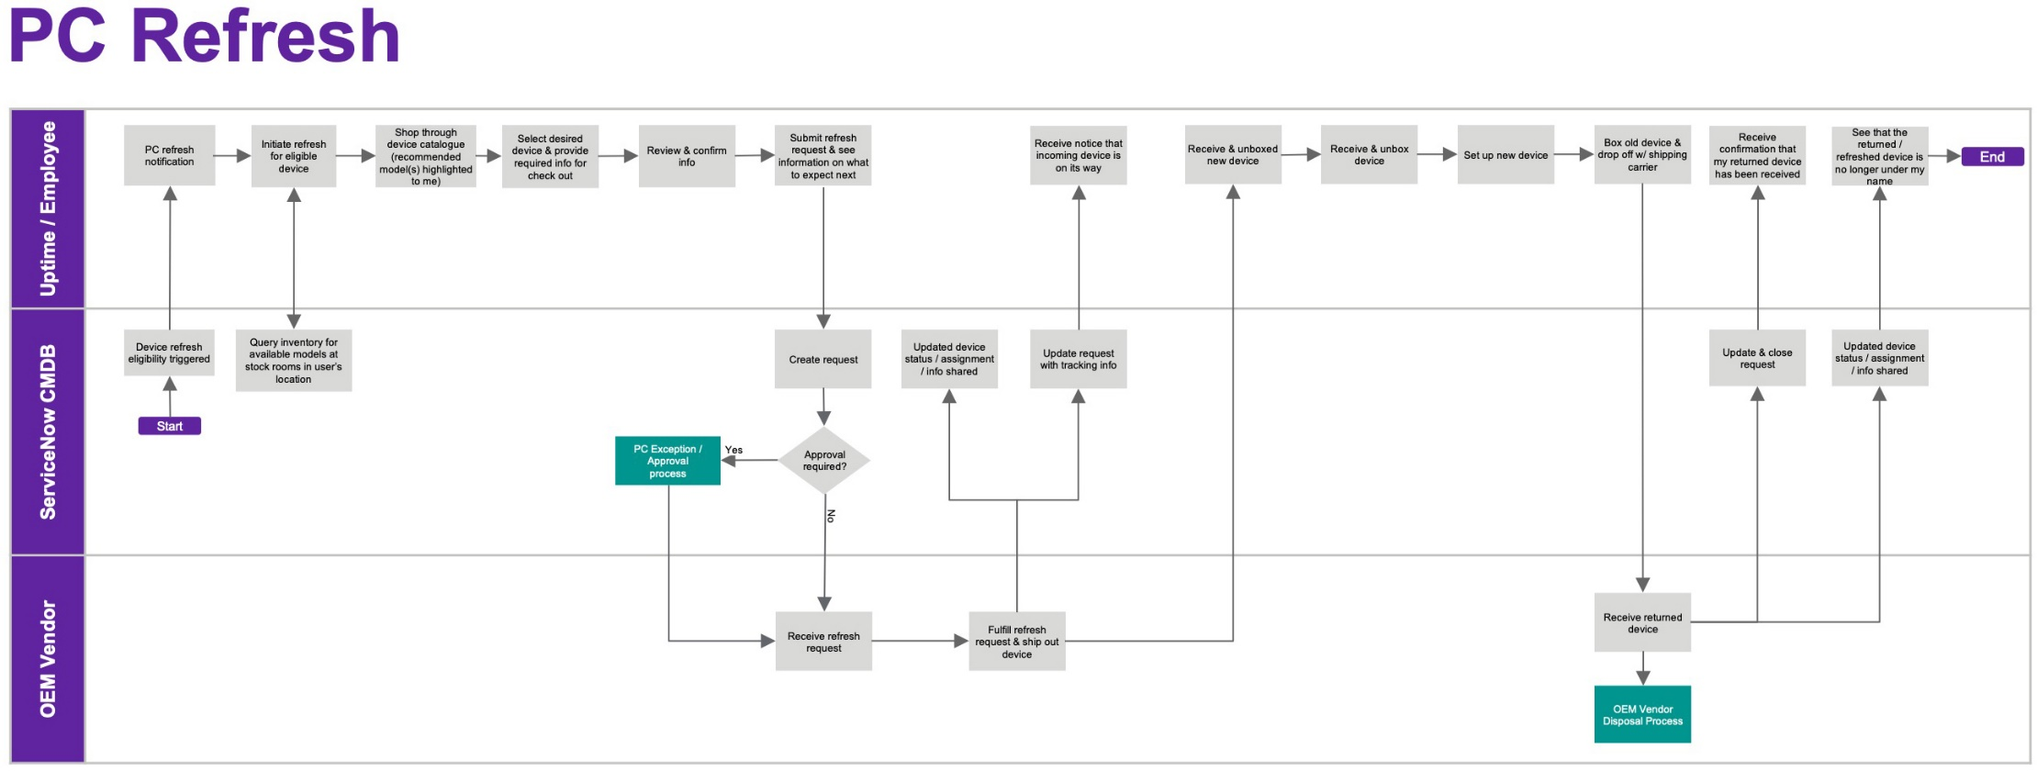

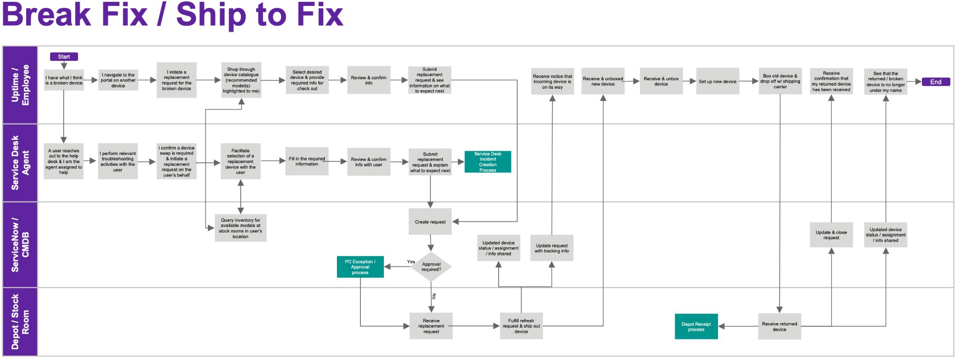

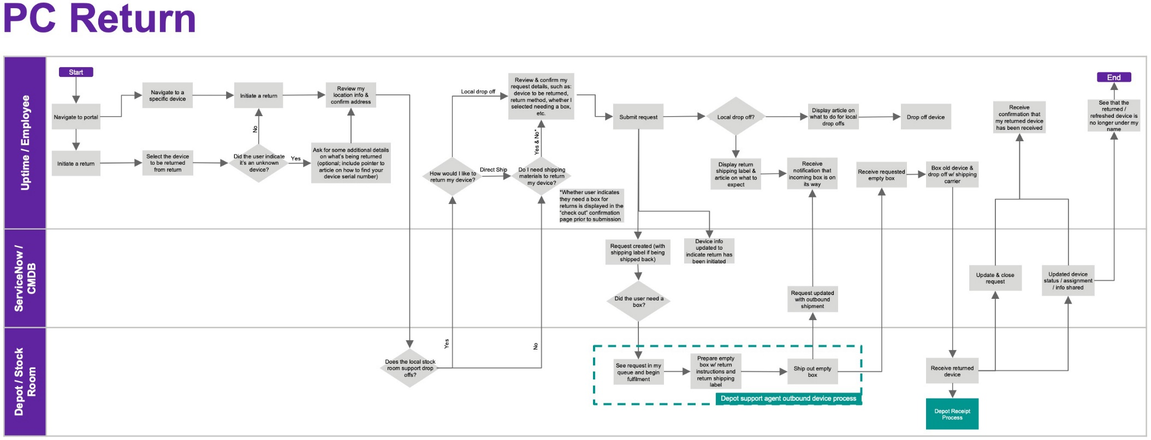

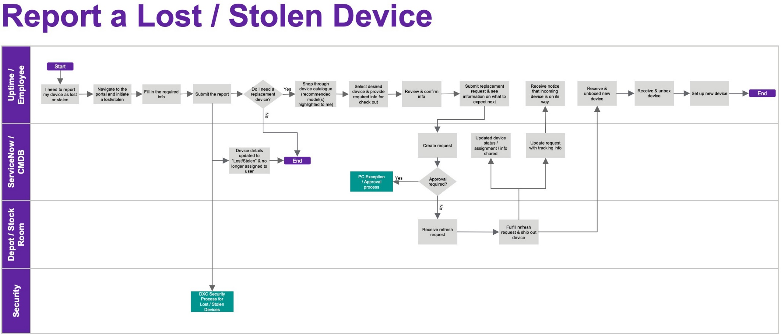

* Knowledge - Entitlement based Knowledge search using UPtime and ServiceNow

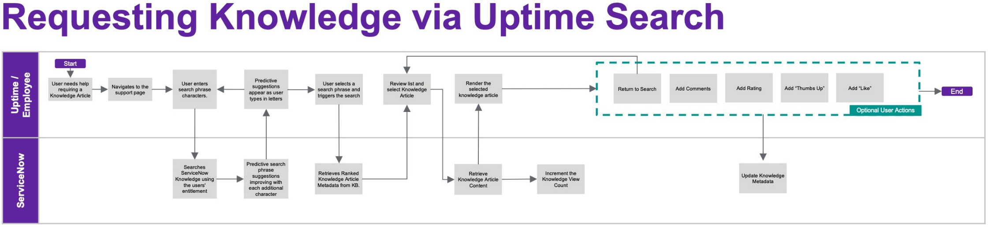

* Agent Chat – Service Desk agent chat, with Sentiment Capture

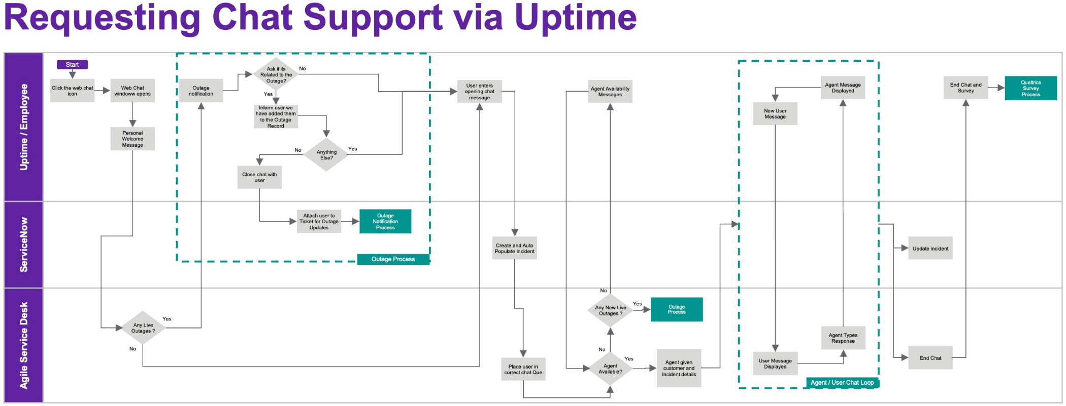

* Software Request
* Software is deployed using user entitlement model, software does not need license verification.

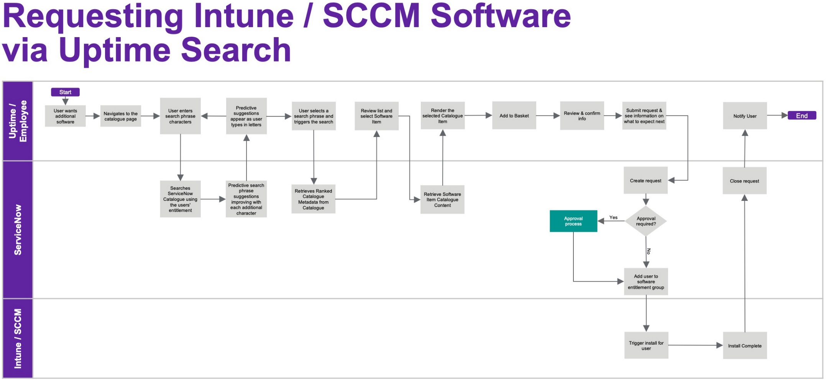

# Develop Solution Strategy – Initial Release (R2)

* In developing the DXC UPtime solution, it is imperative to understand as much of the client’s current Modern Workplace environment (for existing clients) and the requirements from Modern Workplace perspective for an opportunity/deal (new logos) as well as Client Business Objectives and future scope needs to be identified.
* The DXC Uptime Offering is based on a standard service configuration, designed to provide an enhanced user experience. This is based on providing fully integrated and automated Modern Workplace services to customers and to increase the overall value of Modern Workplace services by combining Automation, Analytics, and Intelligence.
* Deal Qualification:
* Besides Digital Support Services and Device Management Services (PC-Lifecycle) as the pre-requisite services that DXC must deliver/propose, and Client owned ServiceNow and/or Platform-X to offer UPtime, Sales/Solution team need to qualify an opportunity whether we can propose UPtime offering.
* UPtime can be offered to existing accounts/clients or new logo/opportunities where DXC provices Modern Workplace sub-offerings with Digital Support Services and Modern Device Management Services as a pre-requisite.

Follow the below flow-chart provides a high-level qualification criterion early during the deal phase. Exceptions will be handled based on the client specific requirements.

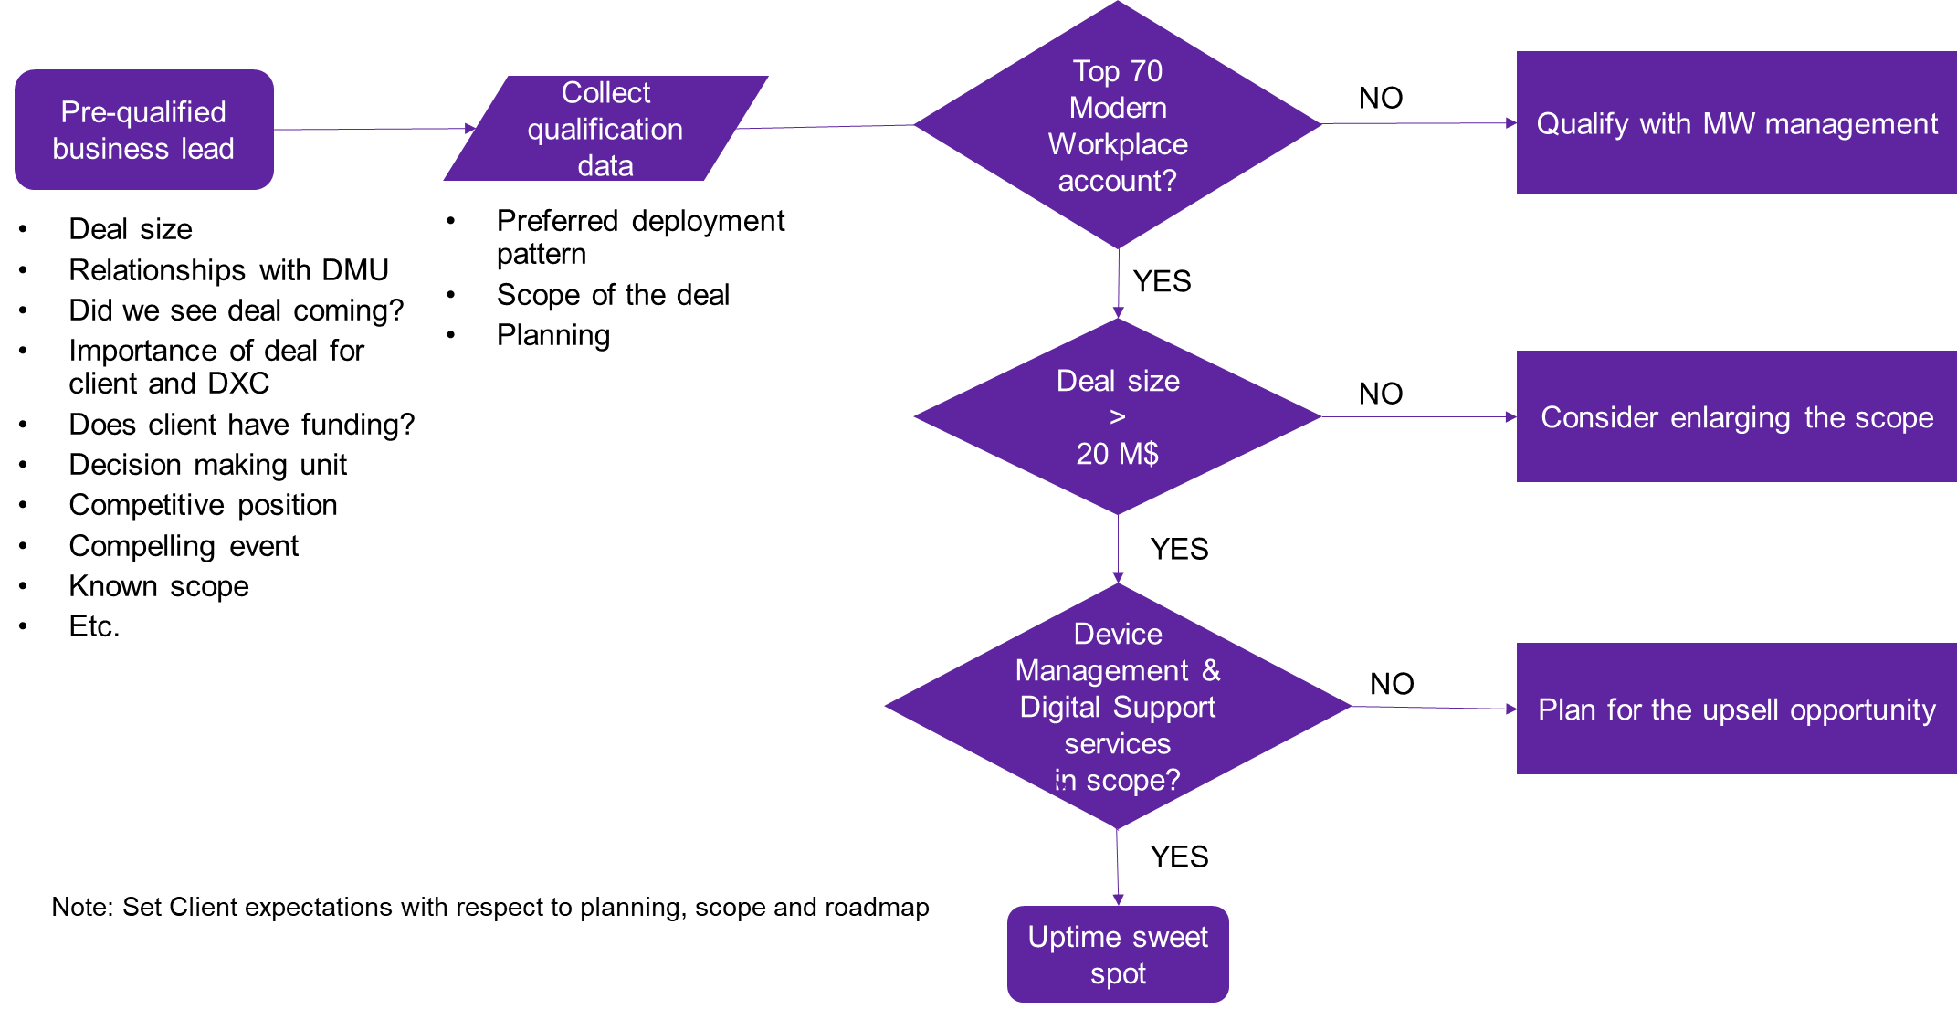

Basic deal qualifications questionnaire for your reference. This may subject to change based on the client specific requirements. Please contact offering team for guidance.

* Existing Client or New Logo?

For existing clients;

* What Modern Workplace offerings/services being delivered?
* Is it one of the Top-70 non-secure Service Desk client?
* Does the client currently use MyWorkPortal solution?
* Fragmented IT support, IT provisioning rather than UX focused?
* Room for Upsell, e.g., PC Lifecycle mgmt., Asset mgmt., etc.
* What ITSM toolsets in use today? Is it Client owned ServiceNow instance, managed by Client or DXC provided Platform-X?

For New Logos;

* What Modern Workplace offerings/services in-scope?
* What ITO service offerings being delivered/in-scope?
* Is Digital Support Services and Modern Device Management service offerings in-scope?
* Do we have DaaS as part of the scope?
* Is Workplace Asset Management and Intelligent Collaboration in-scope?
* What ITSM toolsets in use today? Is it Client owned ServiceNow instance, or offering DXC Platform-X, part of the overall deal?
* What is the projected timeline? CSD/T&T/Go-Live for overall pursuit?
* Is it a pro-active proposal or client showed interested on User Experience?
* Specific User case and Business problem to solve?
* What phase of the deal?
* Client facing Demo presented/required?
* What features that client wants to have with UPtime? Nexthink/1E Tachyon, LogMeIn/AWS Connect, Espressive Barista, Qualtrics XM, etc.
* The solution approach is to utilize standard solution components and methods across Modern Workplace offerings and preferred UPtime deployment patterns. However, each deal is unique and usually has considerations that are not standard. Acquiring the following information will provide enough detail to create a solution for the Develop and Propose phase. Once downselected, confirm the assumptions and data during Due Diligence.

Note: Currently, there is NO guidance from offering team on the minimum users/devices as a baseline to offer UPtime solution.

* UPtime Integrations
* Users accessing the UPtime portal using their corpotate identity services, following the Identity/Multi-Factor authentication mechanism in use. UPtime portal will be integrated with corporate Identity solution following established security guidelines.
* Integration with Platform-X or Client owned ServiceNow Instance. For this version (Release-1/MVP-1) of UPtime, DXC proposes to use dedicated SNOW instance or Platform-X as a pre-requisite for UPtime. Catalogue, Knowledge, Asset, and Incident, etc. are required from IT Service Management (ITSM).
* Integration with backend Knowledge Base Articles for self- help with a mechanism to list top five knowledge base articles either based on frequently accessed in the organization or recently viewed and/or related articles. Access to FAQ’s, Know How’s, Short videos, etc.
* Integration with Platform-X/Ticketing system to view outages, status of the requests raised/access to the previously opened/closed tickets.
* Integration with catalog systems for the users to choose from while opening the service requests.
* Integration with Asset Management System to view the Devices status, ownership, Refresh due, etc.
* Integration with Self Service Password Reset toolsets.
* Integration with Service Desk solution/setup to initiate the Chat (Amazon Connect Chat or MS Teams) as the primary means of interaction/communication with IT Service Desk. Integration with IVR systems to call the Service Desk team for support.
* Integration with intelligent collaboration tools like MS Teams if the chat tool is being identified as a Teams.
* Integration with intelligent collaborations like Exchange/Office 365 for Room reservation solutions.
* Integration with remote access tools like LogMeIn to initiate the remote access to the trouble devices by service desk agents.
* Integration with back-end PC refresh program (Invite only) based on the age of the device.
* Integration with DXC Gear for ordering PC accessories.
* Integration with software asset management solution based on PDXE or flexera to view the software applications installed on the device as well order for additional software mechanism should be in place with the necessary workflows for automated approvals where the software has a dependency on licensing
* Service desk agent’s take chat contacts via the ASD (Amazon connect) channel.
* ServiceNow is used as the system of record for
  + Outages
  + User CMDB
  + Knowledge
  + Catalogue
* Cloud Placement
* Talk about UPtime infrastructure details
* Questionnaire

1. What are the initial BASE costs/efforts to stand-up UPtime End user portal for a client?

* UPtime setup takes ~4 months and 300K USD which spread across all modern workplace offerings in scope for the opportunity. Refer to Modern Workplace Solution 2.0 Learning Sessions (09/01/2021) recordings for more information.

1. Is there an industry/standard guidance to measure User satisfaction? What O-Data/X-Data points to be reviewed/used to measure the User Experience?
2. What is the roadmap? What services/product features are going to be released?
3. What is the journey to get to the target state where UPtime can be deployed?  What offerings do we offer to enable that transformation?
4. What additional components/efforts to be included with UPtime solution? ServiceNow/Nexthink/1E/Teams/Systrack/Intune/ LogMeIn/AWS Connect/DXC Gear)?
5. What compliance/regulatory requirements/certifications to host the portal/data for UPtime solution?
6. What if the backend systems (Multi-channel interfaces for Service Desk, Pro-active/Predictive tools, Device Management solution, etc.) doesn’t have an API/Integration with UPtime, can we offer a custom solution to build the API/Integration? If Yes, who owns the integration activities?
7. What are the initial BASE costs/efforts to stand-up UPtime End user portal for a client?
8. What level customization offered/offered in the standard End User Portal? Who/How owns it and factor efforts for customizations during initial setup/deployment (T&T) and who manages/maintains the customizations during RUN? Need to Identify and Onboard with responsible Team/Resources and Documentation for the same.
9. What is the methodology to manage and maintain user portal (Time, Cost, SOW, SLAs, etc.)?
   1. Subsets of UPtime:
   2. Single Bundle: (Base Model)
   3. Separate Module: (Service Desk / Site Support / Device Management / etc,)
   4. Uplift: (Existing UPtime user)
10. UPtime user portal solution is to offer web based interactive interface to end users with bunch of APIs to integrate with backend services, what is there for Modern Workplace to offer/deliver except the management of API interfaces, web development, etc. which is primarily outside the scope of Modern workplace services? Web/Portal development and/or management including API’s should ideally come from Analytics/Apps team. Modern workplace will consume this service to offer User experience, etc.
11. Interface with corporate HRMS/Directory services to pull user/department/location information?
12. Interface with ASD Voice/Chat based on Amazon Connect Chat services?
13. Interface with pro-active/predictive toolsets to provide the health status of the device/application/network, etc.?
14. Is there an industry/standard guidance to measure User satisfaction? What O-Data/X-Data points to be reviewed/used to measure the User Experience?

* 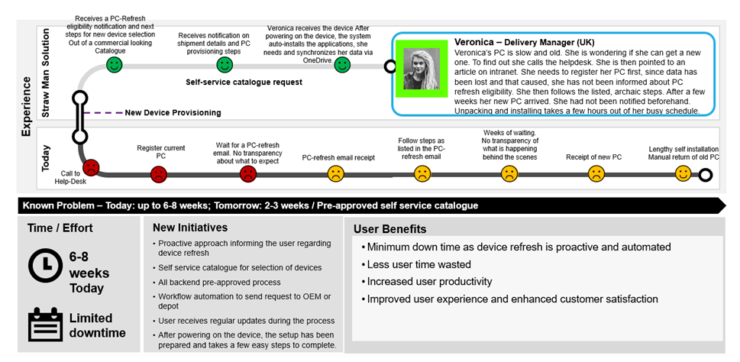User experience examples
* To understand UPtime benefits for end-users a few examples are provided below.
* The first one demonstrates the user experience gains from the re-newed, automated PC-refresh workflow. Assumed is an up to date CMDB database.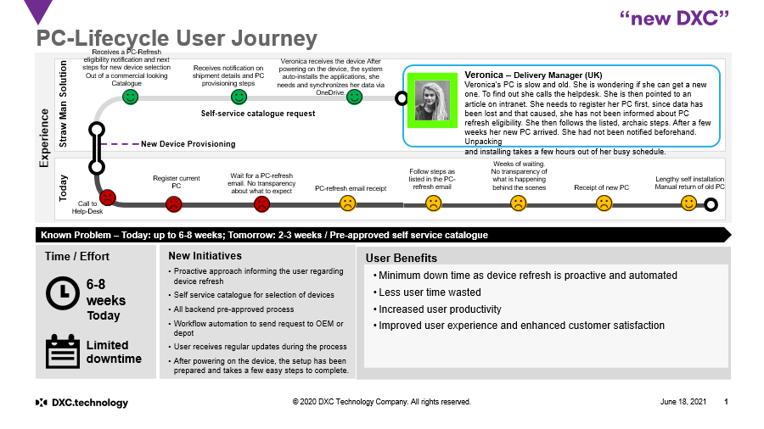
* 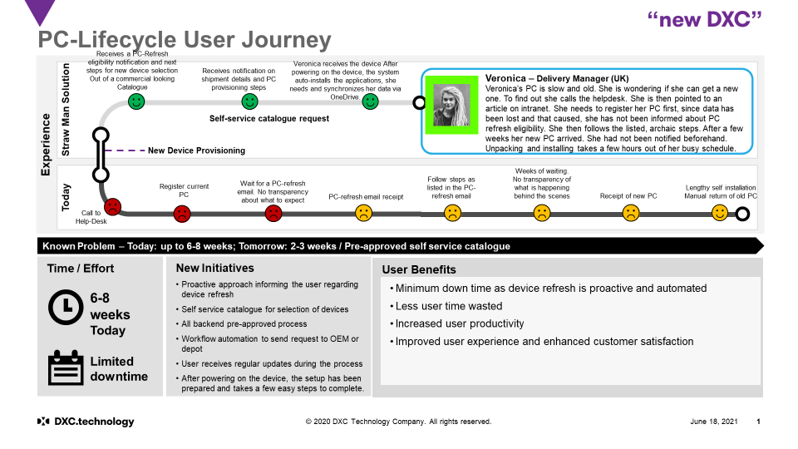

# Management services

### Delivery Location

Management services cover the ongoing management, support, and operations that DXC will perform on behalf of the Customer for the respective Office 365 services. This section provides description of the Management Service that are currently part of the offering.

UPtime, being a Modern Workplace engagement platform tightly integrated with most MW offerings, DXC offering team has identified Manila, Philippines as the default/CoE location to deliver UPtime services globally. Reach out to offering team for exception support requirements to comply with local/regional regulatory/compliance requirements.

Be aware that as part of the DXC UPtime services, DXC UPtime operations team will not provide ongoing support and operations for services listed as integration services. Examples include administration of the 1E Tachyon, Espressive Barista, Knowledge Base Mgmt, Qualtrics XM, etc. which are covered in the respective MW service offerings.

The **key resources** required to deliver most of the UPtime services are **L1, L2 and L3 engineers** as well as a **Client Capability Lead** (CCL). By default, they are **split** between on- and off/best- shore delivery centers (countries) as outlined below:

1. Key roles split between on- and off/best-shore

|  |  |  |  |
| --- | --- | --- | --- |
| Role | On-shore | Off/Best shore | Notes / Comments |
| **L1 Engineers** |  | 100%  **Sample Table** | In the default model, **both** L1 and L2 resources are sourced from off/best-shore locations. |
| **L2 Engineers** |  | 100% |
| **L3 Engineers** | 20% | 80% | The 20% **on**-shore L3 is designed not only for deep technical, but for **client-facing** activities as well |
| **CCL** | 100% |  | The CCL role is heavily involved in customer facing communications and interactions and, by default, is 100% onshore resource. |

### Operational Model

DXC provides **24x7x365** support for the components of the UPtime. services. Keep in mind that this covers **only** the UPtime components. Additional elements – e.g., Azure services, AWS Connect, Device intelligence toolsets (1E, Nexthink), Virtual agent (Espressive Barista), Qualtrics XM, NW connectivity, etc. – which are not native part of the UPtime offering are subject to the operational model of the respective tower. You should synchronize with the respective architect to compile an end-to-end picture.

Responses to inquiries, service requests, and incidents are based on the **priority** of the ticket. Said another way, the service is 24x7x365, but the **response time** varies based on the priority. The following table provides details on the acknowledgement and update times for the different priorities. Business Hours are defined as local time for the respective delivery center, Monday – Friday, 8:00 – 17:00.

1. Incidents Priorities and DXC Acknowledgement and Update Times

|  |  |  |  |
| --- | --- | --- | --- |
| Priority | Description | Example | Customer Updates |
| Priority 1 | Emergency event | Service down for one or multiple end users; site security breach | Acknowledgment within fifteen (15) minutes and hourly updates thereafter |
| Priority 2 | Business critical event | Service degradation to a majority of end users; suspected security vulnerability or attack | Acknowledgment within thirty (30) minutes and updates every two (2) hours thereafter |
| Priority 3 | Important event | Service degradation to a subset of end users; a single end user incident with NO workaround | Acknowledgment within one (1) hour and initial response within four (4) hours with updates every twenty-four (24) hours thereafter |
| Priority 4 | Standard event | Incident impacting a single end user where a workaround exists; routine service requests, inquiries or preventive work | Acknowledgment within four (4) hours and initial response within two (2) business days, with updates every twenty-four (24) hours thereafter up to 14 days. |

### Escalation matrix

DXC acts as the SPOC for any incidents, inquiries, or questions regarding the in-scope UPtime services. DXC will handle, resolve and, when necessary, escalate the ticket to Dell Boomi, OEM, or the responsible third-party vendors.

1. End users raise incidents or submit standard service requests via the usual means – Service. Be aware that the UPtime Delivery Teams are **not** meant to interact directly with end users. Of course, they will support, advice and guide the Service Desk agents in resolving issues but will generally **not communicate** with the users. However, there might be exceptions for VIP users.
2. The ticket / service request reaches the DXC UPtime Delivery Team. This can happen directly in ServiceNow/Platform-X or the DXC Team could also be working in the customer’s ticketing system.
3. The DXC UPtime Delivery Team then start working on incident resolution or standard service requests fulfillment. The DXC Team will escalate and coordinate incidents or requests that are **outside of their control** with respective resolver group. This might include:

* **Other DXC Teams**: e.g., the CPS team responsible for the Azure services of the UPtime infrastructure if it is suspected that Azure services are causing the problem/issue.
* **Customer IT**: It might be that part of the services, related to Uptime, are managed in-house – e.g., if the customer is managing AD with internal IT staff including SSO, MFA, then the DXC teams will escalate any Authentication/Authorization issues to the customer IT department.
* **Dell Boomi**: when applicable, the DXC team will escalate the incident directly to the Dell Boomi support team.

1. In case of an outage or major problem with Uptime, the DXC Team will work with Service Desk to prepare them and Inform customer of the incident and then provide regular updates until the issue is resolved.

### Delivery SPOCs

**Early engagement** and proper communication with involved parties, key persons and Business Units is a crucial part in achieving sound solution. One of the first (and most important) people to talk to about the opportunity are the **Delivery Teams** and **Reviewers**. Discussing the deal details and projected approach with them can bring new ideas to the table as well as common challenges and “lessons learned” from current and previous customers.

Usually, we spend lot of time trying to find the **correct name to connect to**. The table below tries to eliminate this problem with regards to DXC Services for UPtime by listing key persons to be used as a Single Point of Contact (**SPOC**) for the various regions and technologies / components of the offering.

1. SPOCs by Region and Delivery Location for DXC Services for UPtime

|  |  |  |  |
| --- | --- | --- | --- |
| Region | Delivery Location | Name + Link to Email Address | Role / Description |
| WW | Global |  |  |
| AMS | Global |  |  |
| EMEA | Global |  |  |
| APJ | Global |  |  |

You should provide the Datacenter Architect the number of servers, hosting locations, storage requirements, hardware specifications, physical or virtual requirements, backup as well as server- and storage-level High Availability and Disaster Recovery and data replication requirements. Then work together to build the solution and the respective cost model(s) for:

* Hosting
* Server installation (T&T) and Hardware and OS Management (Run)
* SQL installation (T&T) and ongoing support (Run)
* Backup
* Other identified components
* Reporting
* Standard reports include information necessary for SLO measurements. Reports are provided to the client by default. Optional reports and custom reports can be configured at extra cost.

# Develop Solution Cost

* Costing Solution

After properly evaluating the pre-requisites, dependent offerings/services, and determining the scope, the next key step in building the UPtime solution is to cost it. UPtime is heavily dependent on Modern Workplace offerings/services in scope for the opportunity outside of the DXC UPtime offering, that need to be considered and included to build a complete, end-to-end solution. This section provides you with the key data you need to produce a correct cost model and list additional item to consider.

* The main cost drivers are the number of users (Baseline) in scope of Modern Workplace services and the number of MW Cost Models generated for the opportunity/deal. Number of MW cost models are used to equally distribute the T&T and RUN costs among all in-scope Modern Workplace offerings.
* The standard approved Cost Model for UPtime is MW Cost Model tool. UPtime and the supporting documentation are located [here](https://dxcportal.sharepoint.com/sites/MWOfferingCollaterals/Shared%20Documents/Forms/AllItems.aspx?csf=1&web=1&e=9pEjWb&cid=c0139d22%2Db8c0%2D47d6%2Da405%2D54e24aea366c&RootFolder=%2Fsites%2FMWOfferingCollaterals%2FShared%20Documents%2F1%5FDigital%20Support%20Services%2F1%5FDigital%20Support%5FGSD%2FUpTime&FolderCTID=0x01200025EC48799F9BF748B47343717D69191A).
* Note: Please use same number of users across all MW Cost models to provide accurate costs across User experience solution elements, such as UPtime, 1E Tachyon, Qualtrics XM as the costs/licenses are equally distributed among all the in-scope MW cost models.

Note: Consider only the number Cost Models being generated for Modern Workplace offerings, cost models like CPS, Security, I&A should not be considered for costing UPtime solution.

* Costing Tools
* Unlike any other cost model tool within Modern Workplace offerings, UPtime costs will be derived using certain percentage (~1.5%) of total RCOW+CCOW+HW+SW costs for in-scope Modern Workplace cost models. The UPtime portfolio team has created/updated the logic/formulas to calculate the UPtime within [MW Cost Model tool](https://dxcportal.sharepoint.com/:f:/r/sites/workplaceMobilitySolutioning/Offerings/Cost%20Models/MW%20Cost%20Model%20tool?csf=1&web=1&e=k9AmEI) to help you build the UPtime solution cost .The MW Cost Model tool provides fixed one-time transformation costs to stand-up UPtime engagement portal along with necessary integration, workflows with dependent systems along with costs for the ongoing Management Services.
* Note: The information in this section covers the initial release version of the UPtime. The content will be updated to reflect the changes as and when the new features/release of the UPtime made available.
* To build the cost model, following information and steps will be used to provide inputs to the UPtime costing in MW Cost Model tool.
* Download Modern Workplace offering specific cost model/configurator/estimator tool and key in necessary inputs, features, options following the offering specific guidance to generate the offering cost model.
* Create estimator extract from the offering cost model/estimator.
* Download [MW Cost Model tool](https://dxcportal.sharepoint.com/:f:/r/sites/workplaceMobilitySolutioning/Offerings/Cost%20Models/MW%20Cost%20Model%20tool?csf=1&web=1&e=k9AmEI) to generate UPtime and User experience costs to the overall offering specific cost models.
* Use estimator extract as in input for MW Cost Model tool and fill basic information like Number of Client Users and Number of MW Cost Models.
* 
* Note: If the number of Client users as 0 (Zero), MW Cost Model tool assumes UPtime is considered as out of scope and will not populate costs associated with UPtime solution. Please refer MW Cost Model trainings for more information.
* Below is a snapshop of the UPtime T&T and RUN costs as a sample for your reference. Refer to MW Cost Model training videos for more information.
* 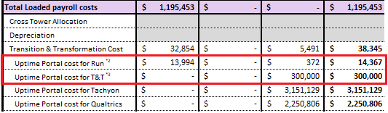

PACE transfer files from respective MW Cost Model tool will be used as input in PACE for final costing and pricing for the opportunity. For information on the process of costing in PACE please see the [Teams](https://teams.microsoft.com/l/team/19%3a4f9c1a4ac96a434caff8b9c70bdc0865%40thread.tacv2/conversations?groupId=07ff1866-a411-4431-a213-15ad74552232&tenantId=93f33571-550f-43cf-b09f-cd331338d086) site for more information specific to the Modern Workplace offerings.

Note: UPtime Solution Reviewer/Approver: At the time of writing this guide, Kaufman, David [david.kaufman@dxc.com](mailto:david.kaufman@dxc.com) is identified to review and approve the UPtime solution approach, costs, timelines, etc. from the Governance perspective.

* Not Included / Custom Costing

This section provides an overview of services and elements that are **not** part of the UPtime costing tool and require custom approach/solution and costing. It also lists additional factors and components that you might need to consider in your model.

If your client specific requirements do not fit in the standard options, in addition to the delivery teams and reviewers, you should contact the DXC UPtime offering team for the custom model. The following UPtime Services are currently not supported by the **costing tool** and require **custom** costing. If you have them in scope of the deal, please contact the offering team for a custom model/guidance:

* ITSM for System of record other than ServiceNow or Platform-X require custom costing for API integrations.
* EU Restrictions – due to various regulations, lot of the European Union (EU) customers require that UPtime delivery teams are in EU-member countries. In that case you should reach out to offering team for guidance.
* In-country delivery restrictions – it is not uncommon customers in highly regulated industries such as Energy Distribution, Power Production, etc. to request the delivery teams to be from the same country as the company. In that case you should reach out to offering team for guidance.
* Be aware that the current operations model does not support non-english languages. Uptime Multi-lingual support will be available in R3 (FY22Q4). However, it is only for UPtime User Interface. UPtime consumes KB articles, ticket details, catalogues from the ITSM system, and these components should be available in other languages so that Uptime can utilize it.

# Security & Privacy

* The solution has been designed for compliance to stringent security and privacy standards.
* Like any other WM offering the following has been conducted:
* US- CATA Architectural assessment
* US-SGRA Compliance Assessment
* DPIA
* US- Security design Review/Security Build Review
* US-Source Code Review
* Web Penetration Test
* Infra Penetration Test
* Results and met security, compliance and privacy standards can be found here:
* For global rollouts the following aspects need to be taken into further considerations:
* Physical location of the users
* Azure cloud components hosting the application and database  
  Refer to:  <https://azure.microsoft.com/en-us/resources/azure-enables-a-world-of-compliance/>
* ServiceNow layer which provides ITSM as a service on AWS

# Transformation Solution - WIP

General steps provided below:

* Request the Azure Subscription
* Provision infrastructure by using Terraform
* Deploy all microservices into environment
* Setup API management
* Setup seed data for CosmosDB
* Ask Testing team to do integration test with latest release for verification

The experience-led transformation framework ensures convergence of human-centred design and embeds the design into DXC’s UPtime solution that provides a set of interactive technologies and operating model to manage and consistently improve the user experience.

The UPtime solution provides the set of interactive technologies which codify the employee user journeys. UPtime enables fast and efficient access for users to view important IT/Support updates, review ticket content and status, receive notifications, request a PC Device lifecycle event e.g., refresh. Search for self-help knowledge articles that will empower productivity and access customer care when technical support is required via any channel preferred, such as chat, text, app, Teams or voice support.

The integration of these channels to UPtime and ServiceNow is achieved via DXC UPtime Action Engine powered by Dell Boomi or native integration service in-built within the products.

A key part of the UPtime Service offering is the Transition and Transformation Methodology. The focus area of the UPtime T&T Methodology is how to Implement/Transform the customer environment, to integrate it with the selected UPtime services and customize, where applicable.

* No fo months for Transition
* UPtime setup takes ~4 months and 300K USD which spread across all modern workplace offerings in scope for the opportunity. Refer to Modern Workplace Solution 2.0 Learning Sessions (09/01/2021) recordings for more information.
* Phases of Transition (Initiate > Discovery > Implement > Pilot > Intergrate)
* Dependencies

Below diagram illustrates the key phases of the UPtime transformation/deployment:

<INSERT IMAGE>

Deep dive into the T&T Methodology is beyond the scope of this Solution Guide. There is an <UPtime Offering Portal> available with in-depth information and collateral for all the phases as well as an extensive set of artefacts. Key parts/components that you are likely to need / use during the solutioning process

* **ITTP Templates** – ready, standardized ITTP templates for common integration and migration scenarios

This doucment is regularly updated with new content which reflect new UPtime services, feedback from various DXC teams as well as lessons learnt from ongoing implementation, integration projects. You should **always** start your UPtime T&T solution with review the latest information published on the site.

* Discovery Workshop

Overview

**UPtime Initial Release (R2)**

* Is for **existing** DXC customers
* Support for new logo is coming in future releases
* Delivered **globally**

The Discovery Workshop for UPtime is, preferably **face to face** (physical presence) workshop. The DXC UPtime T&T team executes it in line with the proposed/agreed schedules. Discovery Workshop is intended to prepare and assist the customers with their UPtime deployment.

Key goal of Discovery Workshop is to ensure a **successful** UPtime implementation and to improve **both** the speed and value of the transformation. To achieve these objectives, the DXC UPtime T&T team will:

* Assess the customer environment
* Review the client’s business requirements and future needs
* Identify planned projects impacting the transformation
* Define integration requirements and Identify roadblocks
* Define/Refine high level timeline

Discovery workshop is typically **up to** an 8-weekengagement. However, this depends on the business priorities as well as DXC and Customer resource availability:

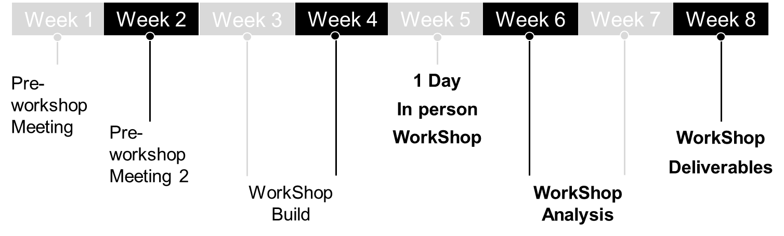

* During the first 2 weeks, DXC leads pre-workshop remote meeting(s). Build all the materials for the workshop so that we quickly dive into the details during the workshop itself
* During the next 2 weeks, we customize the workshop materials to the customer requirements, expectations, and business needs
* Next is the 1 day in person workshop
* Following the workshop delivery, we will analyze the results and provide the following **deliverables**, usually one to two weeks after the in-person workshop:
* High level implementation planning, documented in a **customized ITTP**
* High level Roles and Responsibilities, documented in the **customized ITTP**
* List of Integrations/dependencies
* List of potential **roadblocks** applicable to the customer current and future environments
* A consolidated CMO and FMO description, provided in a **High-Level Design** Document
* Transition and Transformation **pricing**

Solution Approach

**Key Solution Steps**

* Clearly communicate outcomes & benefits
* Validate DXC resource availability
* Build the cost

When you identify an opportunity for the Discovery Workshop, consider the following:

* Discovery Workshop Release 1.0 applies only to **Existing/New-Logo** customers
* The current scope is limited to **User Portal** only
* Identify, educate the resources regionally to take part in Discovery Workshops as necessary.

Team need to ensure to **clearly communicate** the engagement purpose with the customer to avoid setting wrong expectations. Once you reach a common understanding on inputs, purpose and deliverables, the next important step is to identify the DXC resources and validating their availability for the planned delivery time. Calculate the associated cost with the dedicated UPtime T&T Cost Tool. <Link to the tool>

* Transformation Approach
* Transformation/Client On-Boarding Activities (T&T)
* T&T Activities/deliverables
* Project Management Activities for the duration of T&T/On-Boarding activities
* Technical UPtime Implementation/Configuration Team (Team to be Identified) Guidance: Combination of On-shore/Near-Shore resources to interface with Client/Third Party (Incumbent)/Vendor and Team of Resources from Global/Regional Delivery Locations.

Note: Close interlock with T&T team and related documentations

* Custom costing for add-on integration
* Licence / Subscription Cost
* What is the minimum timeline for T & T?
* What are the dependencies

Features:

What are the reports that would be generated from UPtime?

* DXC Support
* Client facing
* Sample Reports

# Partner Strategy

* <Document the approach for including key partners and vendors that are key in developing the Offering Solution>
* Talk about the partners involved in stand-up UPtime and RUN services.
* Talk about process for engegements with UPtime partners.
* Any additional Partner cost to be considered.

# Develop Pricing

*This document target margin(s) for the offering/services*

*Pricing Methodology/Strategy for the offering*

# Reference Information

Initial Release (R2) is primarily targeted for DXCi (DXC Internal) as the first UPtime client. The intent is to learn from DXCi deployment, refine the features and offer UPtime for potential clients. Reference to the list of successful client deployments will be updated in the future.

# Document Control

* Amendment History
* Solution Guide Reviewers & Approvers

# Appendix

* Acronyms

To increase and ease readability, this solution guide uses acronyms. These acronyms are also used in other portfolio collateral such as Tier 1-4 trainings, internal presentations, technical design documents, T&T guides, etc. Please spend some time to familiarize yourself with them. In addition to the table below, all the acronyms are also expanded on first use throughout this document.

|  |  |  |  |  |
| --- | --- | --- | --- | --- |
| Acronym | Meaning / Description |  | Acronym | Meaning / Description |
| XXX | XXXXXXXXXXXX |  |  |  |
|  |  |  |  |  |
|  |  |  |  |  |
|  |  |  |  |  |
|  |  |  |  |  |
|  |  |  |  |  |
|  |  |  |  |  |
|  |  |  |  |  |
|  |  |  |  |  |
|  |  |  |  |  |
|  |  |  |  |  |
|  |  |  |  |  |
|  |  |  |  |  |